**PHYSICS FORM FOUR**

**CHAPTER ONE**

**THIN LENSES.**

***A lens is conventionally defined as a piece of glass which is used to focus or change the direction of a beam of light passing through it.*** They are mainly made of glass or plastic. Lens are used in making spectacles, cameras, cinema projectors, microscopes and telescopes.

Types of thin lenses.

A lens which is thicker at its centre than at its edges converges light and is called **convex or converging lens**. A lens which is thicker at its edges than at its centre diverges light and is known as **concave or diverging lens.**

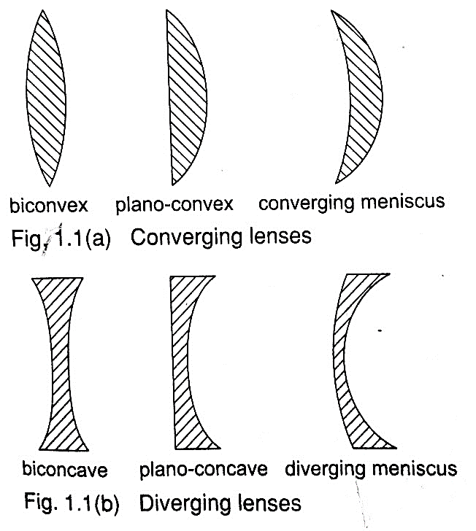

Properties of lenses.

1. Optical centre – this is the geometric centre of a lens which is usually shown using a black dot in ray diagrams. A ray travelling through the optical centre passes through in a straight line.
2. Centre of curvature – this is the geometric centre of the circle of which the lens surface is part of. Since lenses have two surfaces there are two centres of curvature. ***C*** is used to denote one centre while the other is denoted by ***C1***.
3. Principal axis – this is an imaginary line which passes through the optical centre at right angle to the lens.
4. Principal focus – this is a point through which all rays travelling parallel to the principal axis pass after refraction through the lens. A lens has a principal focus on both its sides. **F** is used to denote the principal focus
5. Focal length – this is the distance between the optical centre and the principal focus. It is denoted by ***‘f’****.*

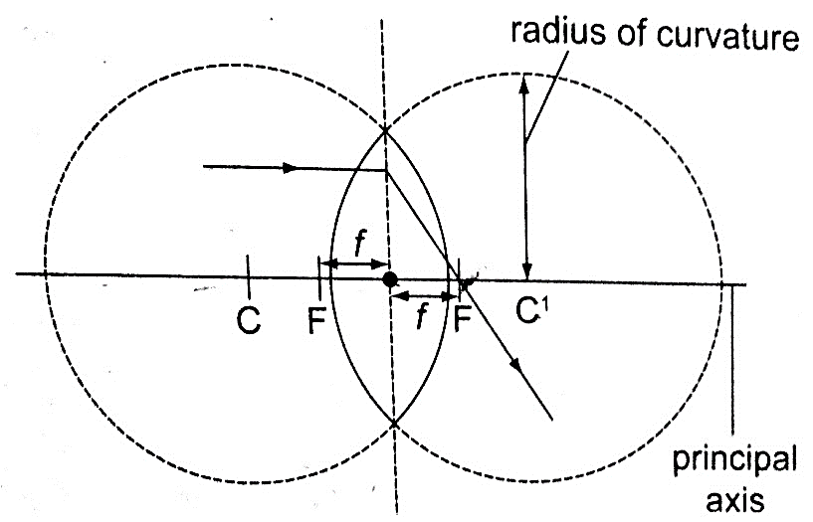

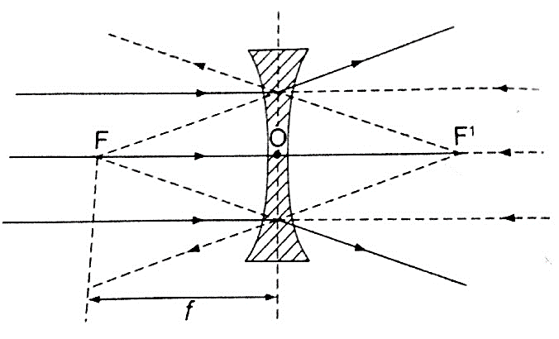The principal focus for a converging lens is real and virtual for a diverging lens. It is important to note that the principal focus is **not always halfway** between the optical centre and the centre of curvature as it is in mirrors.

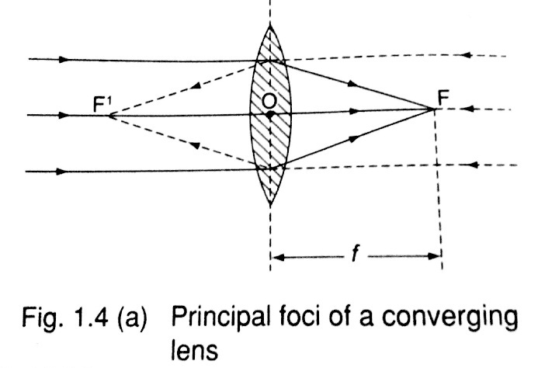

**(b) Principal foci of a diverging lens**

Images formed by thin lenses.

The nature, size and position of the image formed by a particular lens depends on the position of the object in relation to the lens.

*Construction of ray diagrams*

Three rays are of particular importance in the construction of ray diagrams.

1. *A ray of light travelling parallel to the principal axis passes through the principal focus on refraction through the lens. In case of a concave lens the ray is diverged in a way that it appears to come from the principal focus.*
2. *A ray of light travelling through the optical centre goes un-deviated along the same path.*
3. *A ray of light travelling through the principal focus is refracted parallel to the principal axis on passing through the lens. The construction of the rays is illustrated below.*

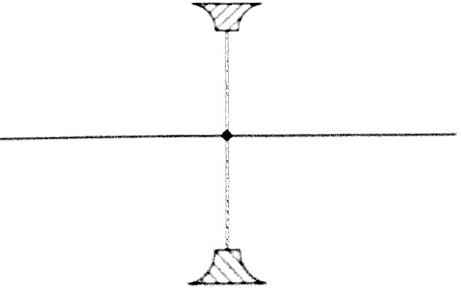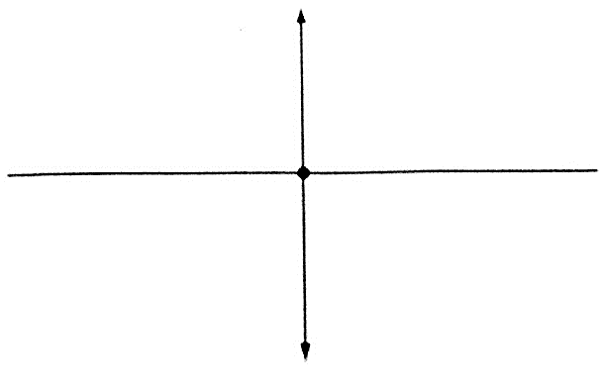

*Images formed by a converging lens.*

1. **Object between the lens and the principal focus.**

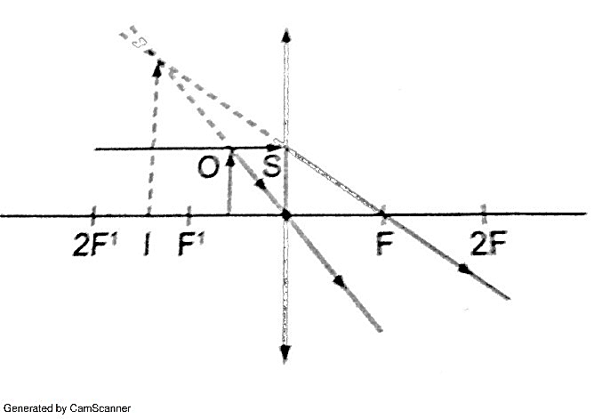

* *Image formed behind the object*
* *Virtual*
* *Erect*
* *Magnified*

1. **Object at infinity.**

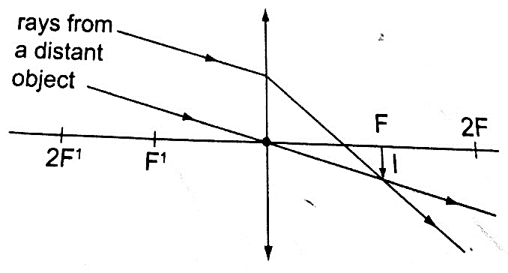

* *Image formed at the principal focus of the lens*
* *Real*
* *Inverted*
* *Diminished*

1. **Object at the principal focus (at F).**

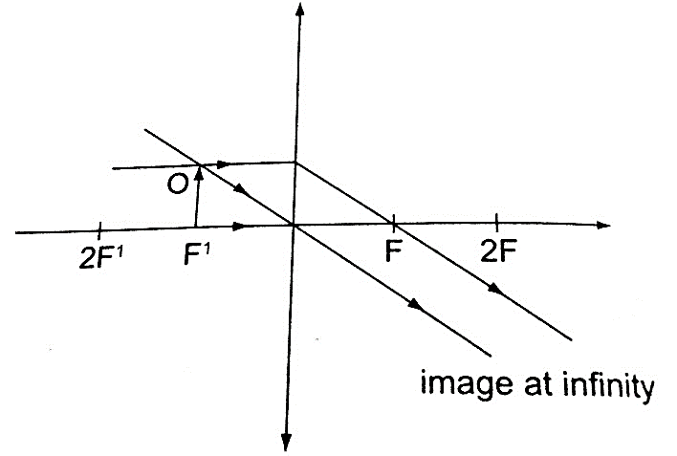

* *Image is at infinity.*

1. **Object between the principal focus (F) and 2 F.**

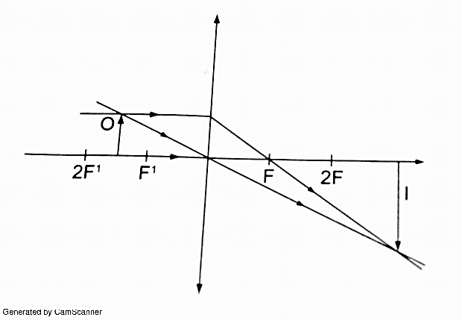

* *Image situated beyond 2 F*
* *Real*
* *Inverted*
* *Magnified*

1. **Object at 2 F.**

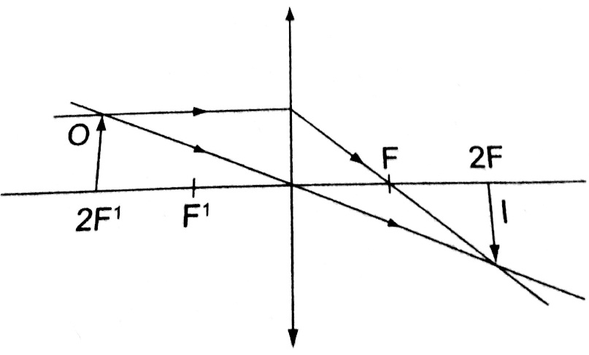

* *Image is formed at 2 F*
* *Real*
* *Inverted*
* *Same size as the object*

1. **Object beyond F.**

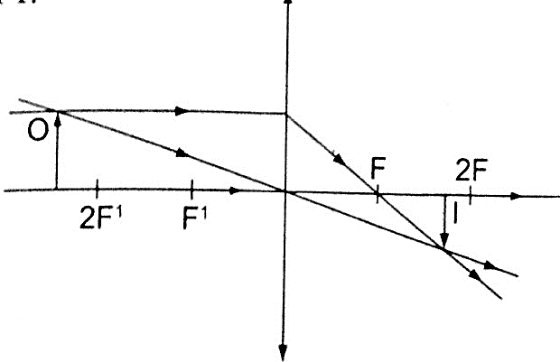

* *Image moves nearer to F as object shifts further beyond 2 F*
* *Real*
* *Inverted*
* *Diminished*

*Images formed by a diverging lens.*

Images formed by diverging lens are always **erect**, **virtual** and **diminished** for all positions of the object.

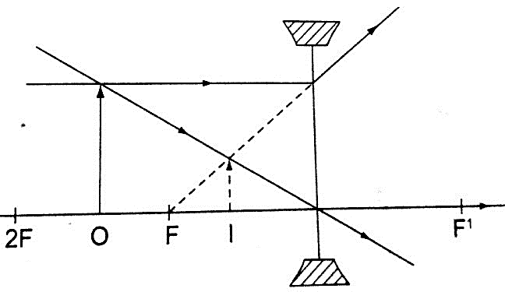

Linear magnification.

***The linear magnification produced by a lens defined as the ratio of the height of the image to the height of the object***, denoted by letter **‘m’**, therefore;

**m = height of the image / height of the object.**

Magnification is also given by **= distance of the image from the lens/ dist. of object from lens.**

**m = v / u**

*Example*

*An object 0.05 m high is placed 0.15 m in front of a convex lens of focal length 0.1 m. Find by construction, the position, nature and size of the image. What is the magnification?*

*Solution*

Let 1 cm represent 5 cm. hence 0.05 m = 5 cm = 1 cm – object height

0.15 m = 15 cm = 3 cm

0.1 m = 10 cm = 2 cm – focal length.

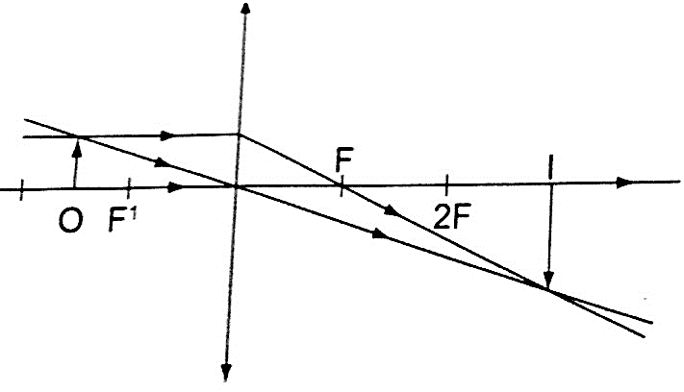

1. Image formed is – image is beyond 2 F

* Inverted
* Real
* Magnified

1. Magnification = v / u = 30 cm / 15 cm = 2.

The lens formula

Let the object distance be represented by **‘u’**, the image distance by **‘v’** and the focal length by **‘*f*’**, then the general formula relating the three quantities is given by;

**1 / *f* = 1 / u + 1 / v** – this is the ***lens formula***.

*Examples*

1. *An object is placed 12 cm from a converging lens of focal length 18 cm. Find the position of the image.*

*Solution*

Since it is a converging lens *f* = +18 cm (real-is-positive and virtual-is-negative rule)

The object is real therefore u = +12 cm, substituting in the lens formula, then

1 / *f* = 1 / u + 1 / v or 1 / v = 1 / *f* – 1 / u = 1 / 18 – 1 / 12 = - 1 / 36

Hence v = - 36 then the image is virtual, erect and same size as the object.

1. *The focal length of a converging lens is found to be 10 cm. How far should the lens be placed from an illuminated object to obtain an image which is magnified five times on the screen?*

*Solution*

*f* = + 10 cm m = v / u = 5 hence v = 5 u

Using the lens formula 1 / *f* = 1 / u + 1 / v => 1 /10 = 1 / u + 1 / 5 u (*replacing v with 5 u*)

1 / 10 = 6 / 5 u, hence 5 u = 60 giving u = 12 cm (*the lens should be placed 12 cm from the illuminated object)*

1. *The lens of a slide projector focuses on an image of height 1.5m on a screen placed 9.0 m from the projector. If the height of the picture on the slide was 6.5 cm, determine,*
2. *Distance from the slide (picture) to the lens*
3. *Focal length of the lens*

*Solution*

Magnification = height of the image / height of the object = v / u = 150 / 6.5 = 900 / u

u = 39 cm (distance from slide to the lens). m = 23.09

1 / *f* = 1 / u + 1 / v = 1 /39 + 1 / 90 = 0.02564 + 0.00111

1 / *f* = 0.02675 (*reciprocal tables*)

f = 37.4 cm.

Determining focal lengths.

1. Determining focal length of a converging lens

***Experiment****: To determine the focal length of a converging lens using the lens formula.*

*Procedure****.***

1. *Set up the apparatus as shown below*

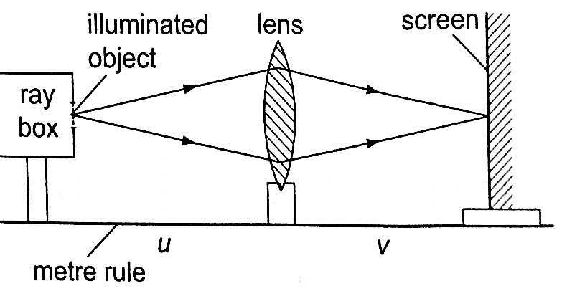

1. *Place the object at reasonable length from the screen until a real image is formed on the screen. Move the lens along the metre rule until a sharply focused image is obtained.*
2. *By changing the position of the object obtain several pairs of value of u and v and record your results as shown.*

|  |  |  |  |
| --- | --- | --- | --- |
| **u** | **v** | **u v** | **u v / u + v** |
|  |  |  |  |

Discussion

The value ***u v / u + v*** is the focal length of the lens and the different sets of values give the average value of ***‘f’***. Alternatively the value ***‘f’*** may be obtained by plotting a graph of ***1 / v*** against ***1 / u.*** When plotted the following graph is obtained.

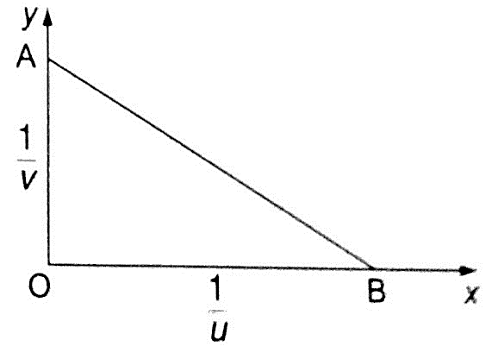

Since ***1 / f = 1 / u + 1 / v***, at the y-intercept ***1 / u = 0***, so that ***1/ f = 1 / v*** or ***f = v.***

The focal length may therefore be obtained by reading off the y-intercept and finding the reciprocal. Similarly at the x-intercept, ***1 / v = 0***, therefore ***1 / f = 1 / u*** or ***f = u*** hence the focal length can also be obtained by reading off the x-intercept and finding the reciprocal.

Uses of lenses on optical devices

1. *Simple microscope*– it is also referred to as magnifying glass where the image appears clearest at about **25 cm** from the eye. This distance is known as the **least distance of distinct vision (D)** or **near vision.**

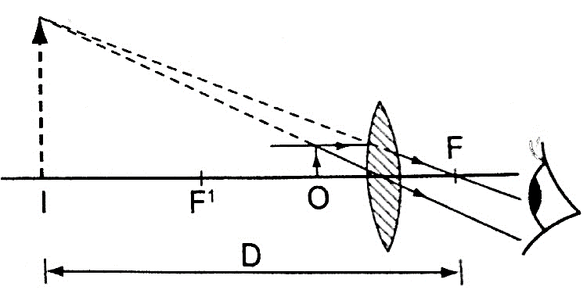

*Magnification in a simple microscope*

Magnification produced depends on the focal length of the lens. Lens of short focal give greater magnification than those of long focal length. The angle ***ϐ*** subtended by the image at the eye is much greater than ***α*** which is the angle that the object would subtend at the eye when viewed without the lens. The ratio of the ***ϐ*** to***α*** is known as **angular magnification** or ***magnifying power*** of an instrument. The angular magnification is equal to linear magnification.

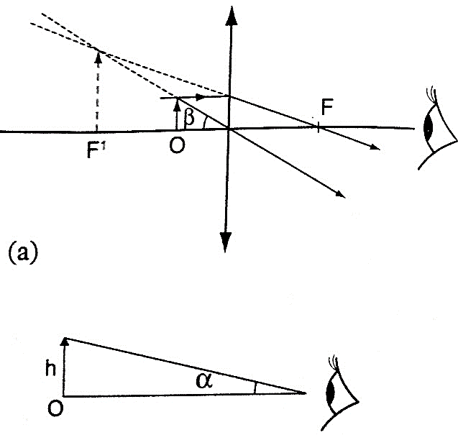

*Uses of a simple microscope*

1. *To study the features of small animals in biology*
2. *To look closely at small print on a map*
3. *To observe crystals in physics and chemistry*
4. *For forensic investigation by the police*
5. Compound microscope - It consists of two lenses with one nearer the object called the objective lens and the other nearer the eye called the eyepiece lens.

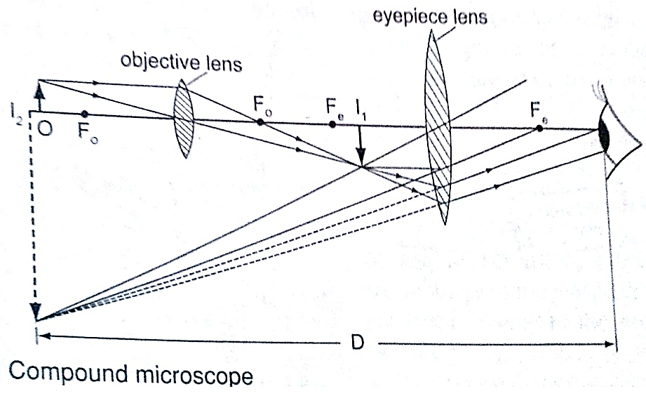

*Uses of compound microscope*

1. *Used to observe Brownian motion in science*
2. *To study micro-organisms and cells in biology*
3. *Analyze laboratory tests in hospital.*
4. The astronomical telescope –It is used to view distant stars. It consists of two lenses; objective and eye-piece lenses. The objective lens has a large focal length while the eye-piece lens has a much shorter focal length.

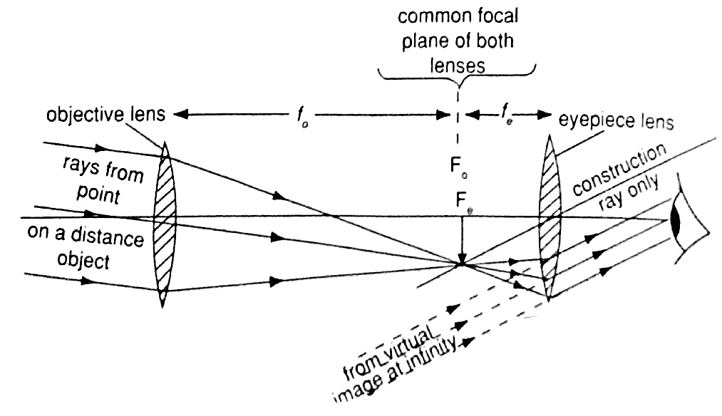

1. The camera – consists of a converging lens system, clicking button, shutter, diaphragm and a mounting base for the film all enclosed in a light proof box. The distance is adjusted to obtain a clear focus. The diaphragm has a hole called the aperture with an adjusting control knob to control the amount of light entering the camera. The shutter opens to allow light and close at a given time interval.

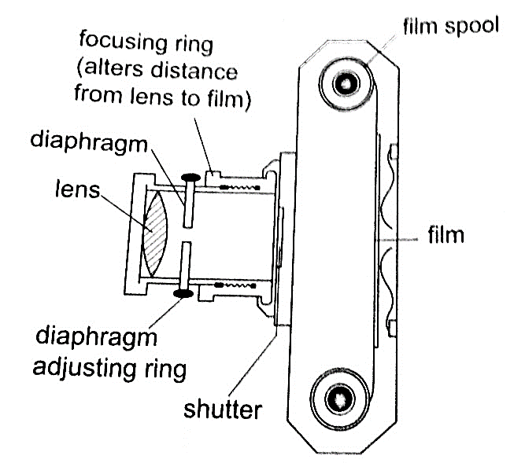

*Uses of a camera*

1. *The sine camera is used to make motion pictures*
2. *High speed cameras are used to record movement of particles*
3. *Close circuit television cameras* ***(CCTV)*** *are used to protect high security installations like banks, supermarkets etc.*
4. *Digital cameras are used to capture data that can be fed to computers.*
5. Human eye – It consists of a transparent cornea, aqueous humour and a crystal-like lens which form a converging lens system. The ciliary muscles contract or relax to change the curvature of the lens. Though the image formed at the retina is inverted the brain ‘sees’ the image as upright. For distant objects ciliary muscles relax while near objects it contracts to control the focal length and this is known as accommodation. When at 25 cmaway an object appears clearest and this is known as least distance of vision or near point.

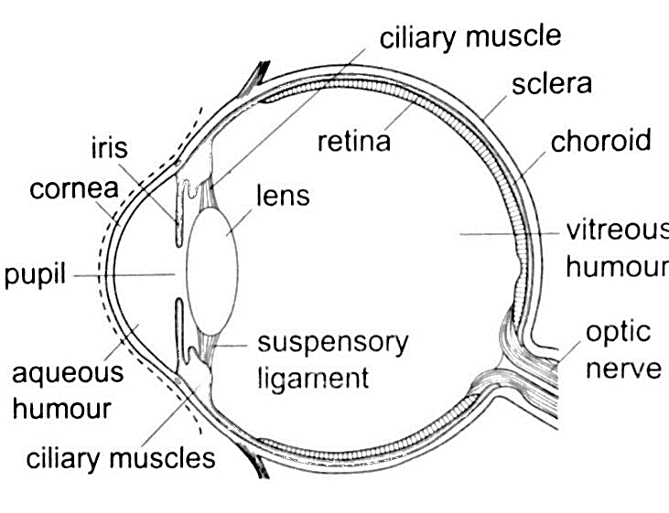

*Common eye defects*

1. *Short sightedness or hypermetropia*– the eyeball is too large for the ‘relaxed focal length’ of the eye. The defect is **corrected** by placing a **concave lens** in front of the eye.

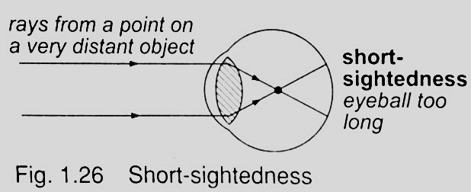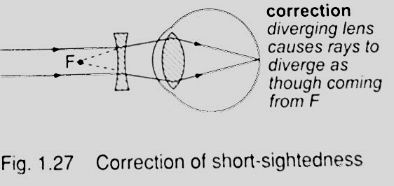

1. *Long sightedness or myopia*– images are formed beyond the retina. The defect is **corrected** by placing a **converging lens** in front of the eye.

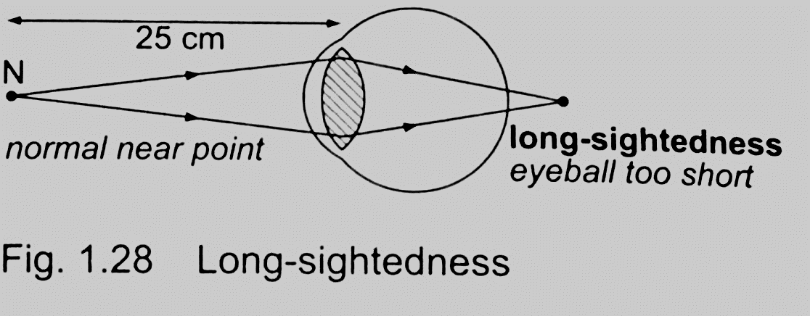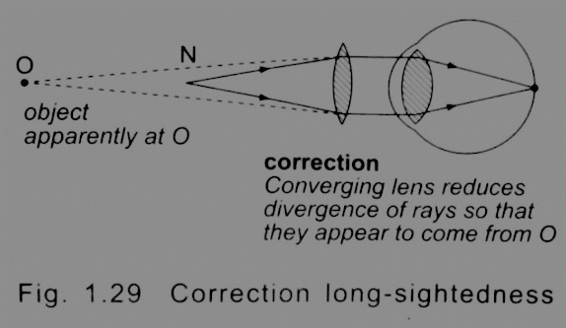

1. *Presbyopia* – this is the inability of the eye to accommodate and this occurs as the eye ages due to the weakening of the ciliary muscles. It can be corrected by the use a pair of spectacles.
2. *Astigmatism* – this is a defect where the eye has two different focal lengths as a result of the cornea not being spherical. Corrected by the use of cylindrical lens.
3. *Colour blindness*– caused by deficiency of colour detecting cells in the retina.

Power of lens

The power of a simple lens is given by the formula: ***Power = 1 / f***. The unit for power of a lens is **diopter (D).**

***Example***

*Find the power of a concave lens of a focal length 25 cm.*

Solution

Power = 1 / *f* = 1 / -0.25 = -4 D.

**CHAPTER TWO**

**UNIFORM CIRCULAR MOTION**

Introduction

***Circular motion*** is the motion of bodies travelling in circular paths. ***Uniform circular motion*** occurs when the speed of a body moving in a circular path is constant. This can be defined as ***motion of an object at a constant speed along a curved path of constant radius.*** When acceleration (variation of velocities) is directed towards the centre of the path of motion it is known as ***centripetal acceleration*** and the force producing this centripetal acceleration which is also directed towards the centre of the path is called ***centripetal force***.

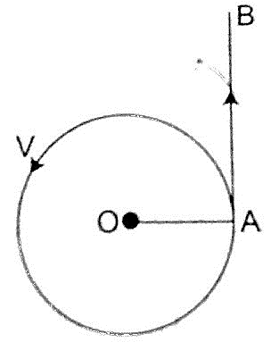

Angular motion

***This motion can be described as the motion of a body moving along a circular path by giving the angle covered in a certain time along the path of motion***. The angle covered in a certain time is proportional to the distance covered along the path of motion.

*The radian*

***One radian is the angle subtended at the centre of the circle by an arc of length equal to the radius of the circle.*** Since one circle = **3600**and has **2 π radians** therefore **1 radian = 3600 / 2 π r= 57.2960 or 57.30.**

*Example*

*A wheel of radius 50 cm is rolled through a quarter turn. Calculate*

1. *The angle rotated in radians*
2. *The distance moved by a point on the circumference.*

*Solution*

1. A quarter turn = 3600 / 4= 900. Since 3600 = 2 π radians.

Alternately since 1 radian = 57.30 hence 900 = 1.57 radii.

1. A point on the circumference moves through an arc,

Arc = radius ×θ (θ in radians)

= 50 cm × 1.57

= 78.5 cm.

Angular velocity

If a body moving in a circular path turns through an angle **θ radians** in time **‘t’**, **we define angular velocity omega (ω), as the rate of change of the angle θ with time.**

**ω= θ / t,** unit for angular velocity is **radians per second (rads-1).** Since the radian measure is a ratio we can write it as **second-1 (s-1).** We can establish the relationship between angular velocity ‘**ω**’ and linear velocity ‘**v**’, from the relation, **θ = arc / radius, arc = radius × θ.**Dividing the expression by ‘**t**’, then **arc / t = radius**, but **arc / t = v (angular velocity).** So **‘v’ = radius × ω.** This expression gives us the relationship between angular and linear velocity.

Angular acceleration

If the angular velocity for a body changes from ‘**ω1**’ to ‘**ω2**’, in time ‘**t**’ then the angular acceleration, **α** can be expressed as;

**α= (ω2 – ω1) / t**

Units for angular acceleration are **radians per second squared (rad s-2)** or **second-2 (s-2).** When **α** is **constant with time, we say the body is moving with uniform angular acceleration.**

Note: In uniform circular motion **α** is equal to zero.

To establish the relationship between angular acceleration and linear acceleration, from the relation, **v = radius × ω**, then dividing by **‘t’**, we get **(v / t) = radius × ω / t.**

But **v / t = a** (*linear acceleration*) and **ω / t = α** (*angular acceleration*).

So **a = radius × α.**

Centripetal force.

***This is a force which acts on a body by directing the body towards its centre***. Since the direction is continuously changing, the velocity therefore cannot be constant.

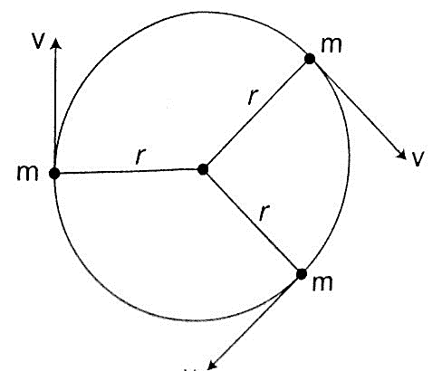

Applying Newton’s law of motion **(F = ma),** the centripetal force **Fc** is given by;

**Fc = ma = mv2/R.** Since **v = radius ω,** then

**Fc = mv2 – ω2/R = mRω2.**

The centripetal **acceleration ‘a’** in relation to **angular velocity, ω,** is given by **a = Rω2.**

Motion in a vertical circle

Consider a mass **‘m’** tied to a string of length **‘r’** and moving in a vertical circle as shown below.

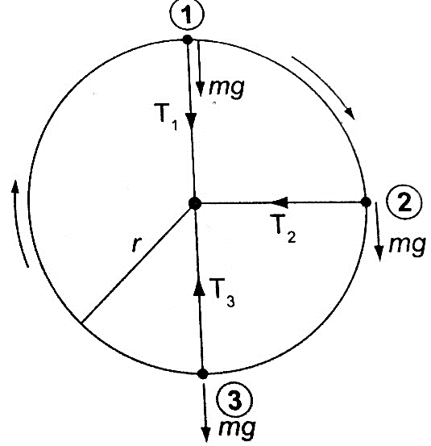

*At position 1*– both weight **(mg)** and tension **T** are in the same direction and the centripetal force is provided by both, hence **T1 + mg = mv2/r. T1 = mv2/r – mg.***(The velocity decreases as* ***T1****decreases since* ***mg*** *is constant).***T1**will be zero when **mv2/r = mg** and thus **v =** *– this is the value of minimum speed at position 1 which keeps the body in a circle and at this time when* ***T = 0*** *the string begins to slacken.*

*At position 2*– the **‘mg’** has no component towards the centre thus playing no part in providing the centripetal force but is provided by the string alone.

**T2 = mv2/r**

*At position 3*– ‘**mg**’ and **T** are in opposite directions, therefore;

**T3 – mg = mv2/r; T3 = mv2/r + mg***– indicates that the greatest value of tension is at* ***T3*** *or at the bottom of the circular path.*

*Examples*

1. *A ball of mass 2.5 × 10-2 kg is tied to a string and whirled in a horizontal circular path at a speed of 5.0 ms-2. If the string is 2.0 m long, what centripetal force does the string exert on the ball?*

*Solution*

Fc = mv2/r = (2.5 × 10-2) × 52 / 2.0 = 0.31 N.

1. *A car of mass 6.0 × 103 kg is driven around a horizontal curve of radius 250 m. if the force of friction between the tyres and the road is 21,000 N. What is the maximum speed that the car can be driven at on a bend without going off the road?*

*Solution*

Fc = force of friction = 21,000, also Fc = mv2/r, hence

21,000 = (6.0 × 103) × v2 / 250, v2 = (21,000 × 250) /6.0 × 103

1. *A stone attached to one end of a string is whirled in space in in a vertical plane. If the length of the string is 80 cm, determine the minimum speed at which the stone will describe a vertical circle. (Take g = 10 m/s2).*

*Solution*

Minimum speed v =  =  × 10 = 2.283 m/s.

The conical pendulum

It consists of a small massive object tied to the end of a thin string tied to affixed rigid support. The object is then pulled at an angle then made to whirl in a horizontal circle.

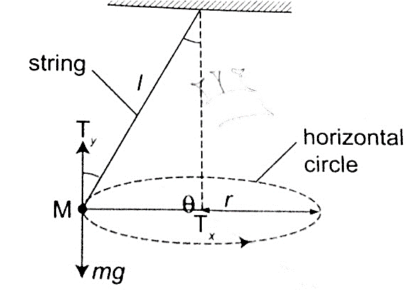

When speed of the object is constant the **angle θ** becomes constant also. If the speed is increased the**angle θ** increases, that is the object rises and describes a circle of bigger radius. Therefore as the angular velocity increases **‘r’** also increases.

The centrifuge

It consists of a small metal container tubes which can be electrically or manually rotated in a circle. If we consider two particles of different masses **m1**and **m2** each of them requires a centripetal force to keep it in circular motion, the more massive particle require a greater force and so a greater radius and therefore it moves to the bottom of the tube.

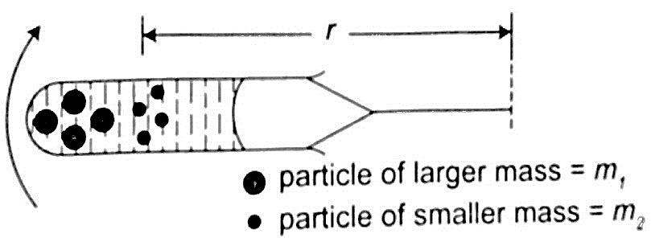

This method is used to separate solids and liquids faster than using a filter paper.

Banked tracks

As a vehicle moves round a bend, the centripetal force is provided by the sideways friction between the tyres and the surface, that is;

**Centripetal force = mv2/r = frictional force**

To enable a vehicle to turn along a bend at high speed the road is raised on the outer edge to attain a saucer-like shape and this is known as banking, where part of the centripetal force necessary to keep the vehicle on track is provided by the weight of the vehicle. This allows cars to negotiate bends at critical speeds.

Application of uniform circular motion

1. *Centrifuges* - they are used to separate liquids of different densities i.e. cream and milk
2. *Drying clothes in spin dryer*- clothes are placed in a perforated drum rotated at high speed, water is expelled through the holes and this makes the clothes dry.
3. *Road banking*– especially for racing cars which enables them to move at critical speed along bends without going off the tracks.
4. *Speed governor*– the principle of conical pendulum is used here to regulate the speed by controlling the fuel intake in the combustion chamber. As the collar moves up and down through a system of levers it thereby connects to a device which controls the fuel intake.

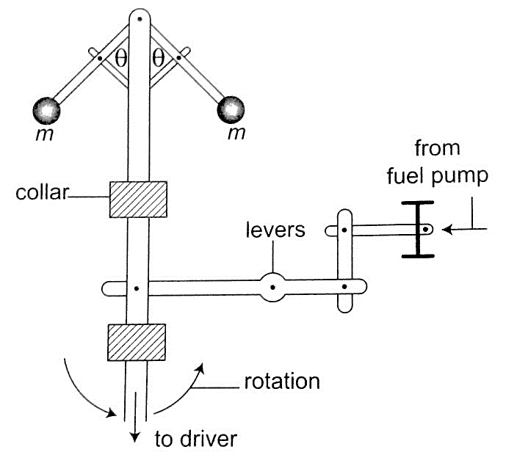

**CHAPTER THREE**

**FLOATING AND SINKING**

Any object in a liquid whether **floating** or **submerged** experiences an **upward force** from the liquid; the force is known as **upthrust force**. **Upthrust force** is also known as **buoyant force** and is denoted by letter **‘u’**.

Archimedes’ principle

Archimedes, a Greek scientist carried out first experiments to measure upthrust on an object in liquid in the third century. **Archimedes principle** states that ***‘When a body is wholly or partially immersed in a fluid (liquid/ gas), it experiences an upthrust equal to the weight of the displaced fluid”.***

*Experiment: To demonstrate Archimedes principle*

*Procedure*

1. *Pour water into an overflow can (eureka can) until it starts to flow out then wait until it stops dripping*
2. *Tie a suitable solid body securely and suspend it on a spring balance. Determine weight in air.*
3. *Lower the body slowly into the overflow can while still attached to the spring balance then read off its weight when fully submerged.*
4. *Weigh the displaced water collected in a beaker. Record your readings as follows;*

*Weight of body in air =* ***W1***

*Weight of body in water =* ***W2***

*Weight of empty beaker =* ***W3***

*Weight of beaker and displaced liquid =* ***W4***

*Upthrust of the body =* ***W1 – W2***

*Weight of displaced water =* ***W4 – W3***

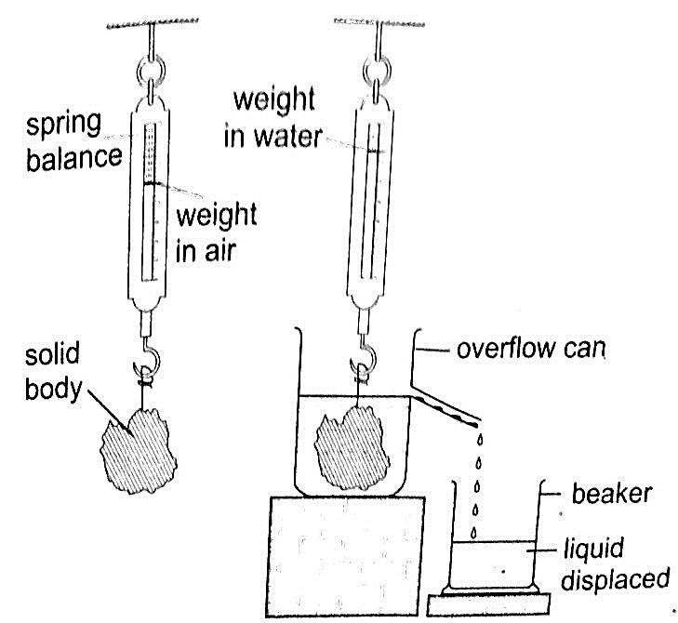

*Discussion*

The upthrust on the solid body will be found to be equal to the weight of displaced water therefore demonstrating the Archimedes principle.

*Example*

*A block of metal of volume 60 cm3 weighs 4.80 N in air. Determine its weight when fully submerged in a liquid of density 1,200 kgm-3.*

*Solution*

Volume of liquid displaced = 60 cm3 = 6.0 × 10-5 m3.

Weight of the displaced liquid = volume × density × gravity = v × ρ × g

= 6.0 × 10-5 × 1200 × 10

= 0.72 N

Upthrust = weight of the liquid displaced.

Weight of the block in the liquid = (4.80 – 0.72) = 4.08 N.

Floating objects

***Objects that float in a liquid are less dense than the liquid in which they float***. We have to determine the relationship between the weight of the displaced liquid and the weight of the body.

Experiment: to demonstrate the law of floatation

Procedure

1. *Weigh the block in air and record its weight as* ***W1****.*
2. *Put water into the overflow can (eureka can) up to the level of the spout.*
3. *Collect displaced water in a beaker. Record the weight of the beaker first in air and record as* ***W2****. Weigh both the beaker and the displaced water and record as* ***W3.***
4. *Record the same procedure with kerosene and record your results as shown below.*

|  |  |  |  |  |
| --- | --- | --- | --- | --- |
|  | **W1** | **W2** | **W3** | **W3 – W2** |
| Water |  |  |  |  |
| Kerosene |  |  |  |  |

1. *What do you notice between* ***W1*** *and* ***W3 – W2***

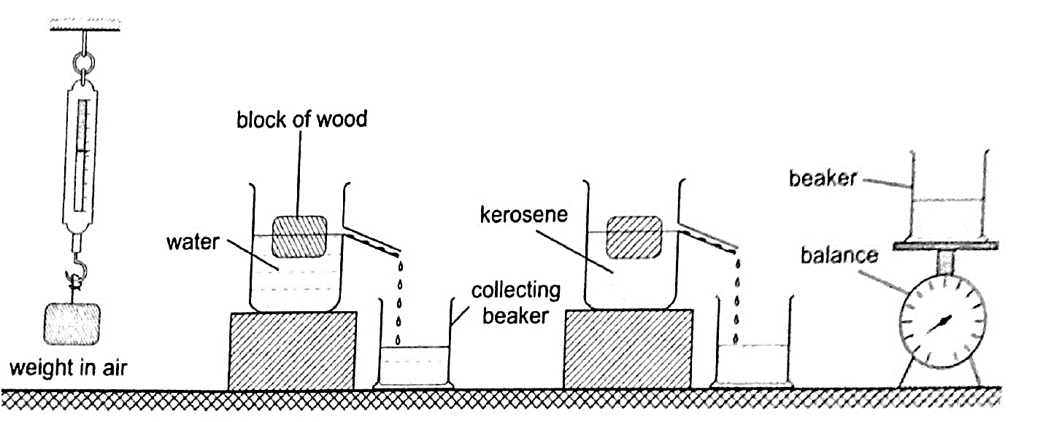

*Discussion*

The weight of the displaced liquid is equal to the weight of the block in air. This is consistent with the law of floatation which states ***that “A body displaces its own weight of the liquid in which it floats”***. Mathematically, the following relation can be deduced

**Weight = volume × density × gravity = v × ρ × g,** therefore

**W = v d × ρ × g***where* ***vd****is the volume of displaced liquid.*

NOTE – ***Floatation is a special case of Archimedes principle. This is because a floating body sinks until the upthrust equals the weight of the body.***

*Example*

*A wooden block of dimensions 3 cm × 3 cm × 4 cm floats vertically in methylated spirit with 4 cm of its length in the spirit. Calculate the weight of the block. (Density of methylated spirit = 8.0 × 102 kgm-3).*

*Solution*

Volume of the spirit displaced = (3 × 3 × 4) = 36 cm3 = 3.6 × 10-5 m3

Weight of the block =v d × ρ × g = (3.6 × 10-5) × 8.0 × 102 × 10 = 2.88 × 10-1 N.

Relative density

***We have established the relative density as the ratio of the density of a substance to the density of water***. Since by the law of floatation an object displaces a fluid equal to its own weight hence the following mathematical expressions can be established.

***Relative density = density of substance / density of water.***

***= weight of substance / weight of equal volume of water***

***= mass of substance / mass of equal volume of water***

Applying Archimedes principle, the relative density‘d’**;**

***d = weight of substance in air / upthrust in water or d = W / u***

Since upthrust is given by **(W2 - W1)***where* ***W2*** *– weight in air,* ***W2****– weight when submerged.*

Hence **d = W / u = W / W2 – W1**, the actual density, ***ρ*** of an object can be obtained as follows

***ρ* of an object = d × 1,000 kgm-3.**

Relative density of a floating body

*Experiment: To determine the relative density of a cork*

*Procedure*

1. *Select a sinker which is heavy enough to make the cork to sink.*
2. *Attach the cork and the sinker as follows*

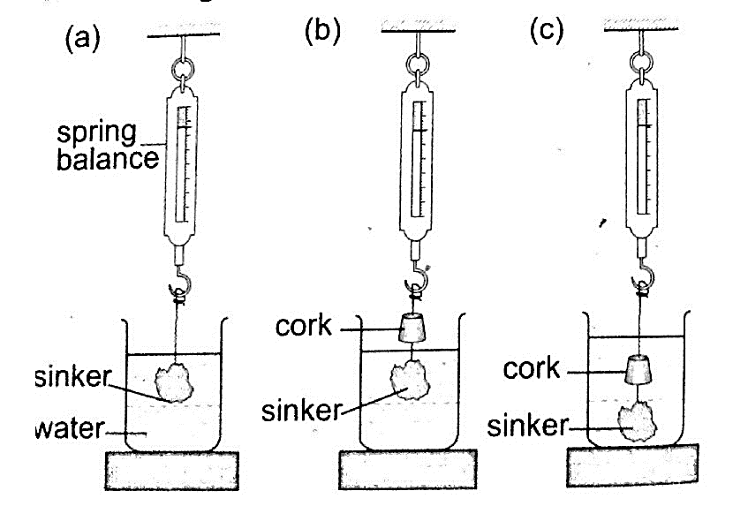

1. *Record the results obtained as follows*

*Weight of the sinker in water =* ***W1***

*Weight of the sinker in water and cork in air =* ***W2***

*Weight of the sinker and cork in water =* ***W3***

*Weight of the cork in air =* ***W2 – W1***

*Upthrust on the cork =* ***W2 – W3***

The relative density of the cork in air is determined as follows;

***d = weight of the cork in air / upthrust on the cork.***

Applications of Archimedes principle and relative density

1. *Ships* – steel which is used to make ships is 6-7 times dense than water but a ship is able to float on water because it is designed to displace more water than its volume. Load lines called plimsoll marks are marked on the side to indicate the maximum load at different seasons to avoid overloading.
2. *Submarines* – they are made of steel and consists of ballast tanks which contain water when theyhave to sink and filled with air when they have to float. This makes the submarines to balance their weight and be able to rise upwards.
3. *Balloons* – when they are filled with helium gas balloons become lighter and the upthrust on the balloon becomes greater than their weight therefore becoming able to rise upwards.
4. *Hydrometers* – they are used to measure the relative densities of liquids quickly and conveniently. Various types of hydrometers are made to measure different ranges of different densities i.e. ***lactometer*** *– for measuring milk water (range* ***1.015 – 1.045****),* ***battery acid tester*** *– used to test the charge in a lead-acid battery.*

***Examples***

1. *A solid of mass 1.0 kg is suspended using a thread and then submerged in water. If the tension on the thread is 5.0 N, determine the relative density of the solid.*

*Solution*

Mass of solid = 1.0 kg

Weight of solid W = mg = 10 N

Tension on the string (T) = 5 N

Upthrust on solid (u) = W – T = 10 – 5 = 5

Relative density (d) = W / u = 10 / 5 = 2.

1. *A balloon made up of a fabric weighing 80 N has a volume of 1.0 × 107 cm. the balloon is filled with hydrogen of density 0.9 kgm-3. Calculate the greatest weight in addition to that of the hydrogen and the fabric, which the balloon can carry in air of average density 1.25 kgm-3.*

*Solution*

Upthrust = weight of the air displaced

= volume of air × density × gravity

= (1.0 × 107 × 106) × (1.25 × 10)

= 10 × 1.25 × 10 = 125 N

Weight of hydrogen = 10 × 0.09 × 10 = 9 N

Total weight of hydrogen and fabric = 80 + 9 = 89 N

Total additional weight to be lifted = 125 – 89 = 36 N.

1. *A material of density 8.5 gcm-3 is attached to a piece of wood of mass 100g and density 0.2 gcm-3. Calculate the volume of material* ***X*** *which must be attached to the piece of wood so that the two just submerge beneath a liquid of density 1.2 gcm-3.*

*Solution*

Let the volume of the material be V cm3

The mass of the material be 8.5 V grams

Volume of wood = 100 g / 0.2 g/cm = 500 cm3.

In order to have an average density of 1.2 gcm-3 = total mass / total volume

Therefore (100 + 8.5V) / (500 + V) = 1.2 gcm-3

Hence V = 68.5 cm3.

**CHAPTER FOUR**

**ELECTROMAGNETIC SPECTRUM**

***Electromagnetic spectrum is a continuum of all electromagnetic waves arranged according to frequency and wavelength.*** It includes visible light, ultra-violet rays, microwaves, X-rays, radio waves and gamma rays. Electromagnetic waves are produced when electrically charged particles oscillate or change energy in some way. The waves travel **perpendicularly** to both **electric** and **magnetic fields**.

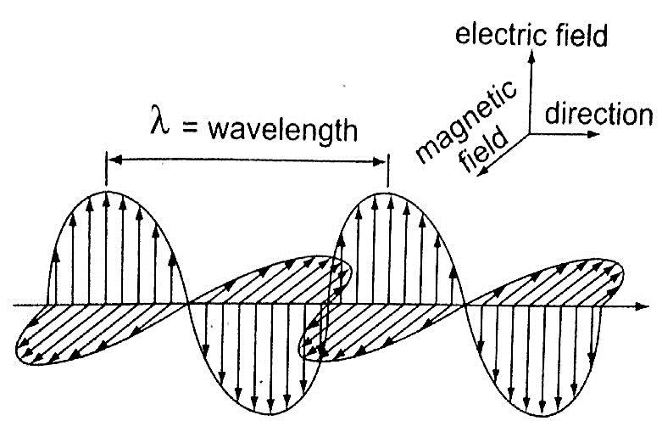

*Wavelength, frequency and energy of electromagnetic waves.*

**X-rays** and **gamma rays** are usually described in terms of **wavelength** and **radio waves** in terms of **frequency.**

The electromagnetic spectrum

It is divided into **seven** major **regions** or **bands**. A band consists of a range of frequencies in the spectrum in terms of frequencies i.e. radio, microwaves, infra-red.

Properties of electromagnetic waves

*Common properties*

1. *They do not require a material medium and can travel through a vacuum.*
2. *They undergo reflection, refraction and diffraction.*
3. *All electromagnetic waves travel at the speed of light i.e.* ***3 × 108 ms-1.***
4. *They carry no electric charge*
5. *They transfer energy from a source to a receiver in the form of oscillating electric and magnetic fields.*
6. 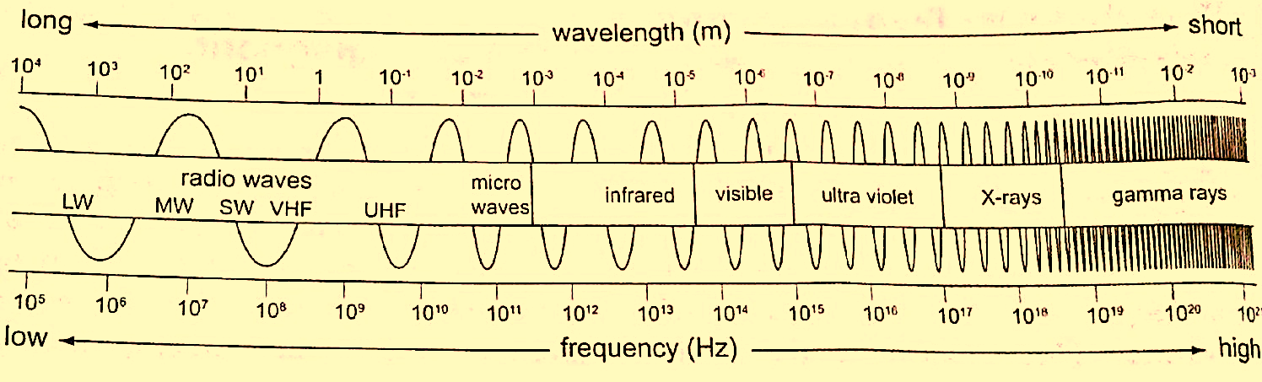*They obey the wave equation (****v = λ f****).*

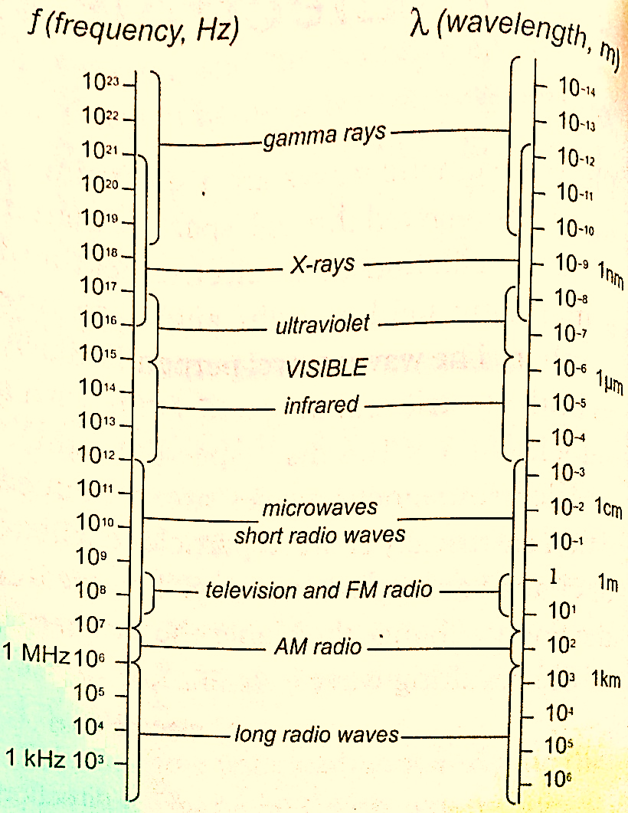

***Examples***

1. *A VHF radio transmitter broadcasts radio waves at a frequency of 30 M Hz. What is theirwavelength?*

*Solution*

v = *f* λ => then λ = v / *f* = 3.0 × 108 / 300 × 106 = 1.00 m.

1. *Calculate the frequency of a radio wave of wavelength 150 m.*

*Solution*

v = *f* λ =>*f* = v / λ = 2.0 × 106 = 2 M Hz.

Unique properties

1. Radio waves– they are further divided into **long waves (LW**), **medium waves (MW)** and **short waves (SW).** They are produced by electrical circuits called **oscillators** and they can be controlled accurately. They are easily diffracted by small objects like houses but not by large objects like hills.
2. Microwaves – they are produced by oscillation of charges in special aerials mounted on dishes. They are detected by special receivers which convert wave energy to sound i.e. **‘RADAR’ – Radio Detection and Raging.**
3. Infra-red radiation – infra-red radiations close to microwaves are **thermal** (produce heat) i.e. sun, fire but those closer to the visible light have no thermal properties i.e. TV remote control system. Detectors of infra-red radiation are the human skin, photographic film etc.
4. Optical spectrum (visible light) – they form a tiny part of the electromagnetic spectrum. Sources include the sun, electricity, candles etc. these have wavelengths visible to the human eye and includes the **optical spectrum (ROYGBIV).** It is detected through the eyes, photographic films and photocells.
5. Ultra-violet rays (UV) – has shorter wavelength than visible light. It is emitted by very **hotobjects** i.e. the sun, welding machines etc. Exposure to UV rays may cause skin cancer and cataracts. They can be detected through photographic film.
6. X-rays – they have very short wavelength but are high energy waves. They are produced in X-ray tubes when high speed electrons are stopped by a metallic object. They are detected by the use of a photographic film or a fluorescent screen.
7. Gamma rays – produced by some radioactive materials when large changes of energy occur inside their nuclei. They can be detected by the use of photographic films, Geiger Muller tube or a cloud chamber.

Applications of electromagnetic radiation

1. *Radio waves – they are used in radio, TV and cellular mobile communications.*

*-Used in military communications (satellite imagery) to form an image of the ground even when there are clouds.*

1. *Microwaves - used in radar communications by giving direction and distance.*

*-Used in speed guns by the police to detect over speeding.*

*-Used in microwave ovens to warm food. The food becomes warm by absorbing energy.*

*-Used reliably for communication (telephone and computer data).*

1. *Infra-red radiation - used to produce images of hot objects through the colours*

*-Produced by the amount of heat dissipated by an object.*

*-Images produced by satellites give important information on vegetation cover in all areas of the globe. They can also detect fires.*

*-They are used in hospitals to detect illnesses (diagnosis)*

*-Used in warfare missiles and burglar alarm systems*

*-Used in green houses to grow crops*

1. *Visible light - used by plants in remote sensing and humans in the identification of things*

*-Used by plants in the process of photosynthesis*

1. *Ultra-violet (UV) radiation – used to make reflective materials which absorb light and*

*re-emit it as visible light.*

*-Used in banks to detect fake currency*

1. *X-rays - used in hospitals to detect fractures, broken bones and in treatment of*

*cancer (radiotherapy).*

*-Used to detect foreign materials in the body i.e. metals*

*-Used to detect invisible cracks in metal castings and welding joints*

1. *Gamma rays - used to sterilize medical instruments*

*-Used to kill weevils in grain*

*-Used to take photographs same way like X-rays.*

**CHAPTER FIVE**

**ELECTROMAGNETIC INDUCTION**

***Electromagnetism is the effect resulting from the interaction between an electric current and a magnetic field.*** This effect brings about induced electromagnetic force (e.m.f) and the resulting current is called induced current.

*Experiments on electromagnetic induction*

Consider the following diagram

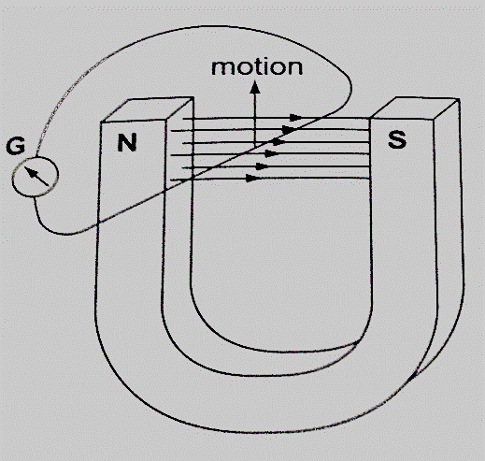

When the wire is moved up the galvanometer deflects in one direction then the opposite direction when moved downwards. When moved horizontally or held in a fixed position there is no deflection in the galvanometer. This shows that e.m.f is induced due to the relative motion of the wire or the magnet.

Factors affecting the magnitude of the induced e.m.f

1. ***The rate of relative motion between the conductor and the field*** – if the velocity of the conductor is increased the deflection in the conductor increases.
2. ***The strength of the magnetic field*** – a stronger magnetic field creates a bigger deflection
3. ***The length of the conductor*** – if the length is increased in the magnetic field the deflection increases.

Faraday’s law of magnetic induction

After considering the factors affecting the magnitude of the induced e.m.f, Michael Faraday came up with a law which states that ***“The induced e.m.f in a conductor in a magnetic field is proportional to the rate of change of the magnetic flux linking the conductor”.***

Lenz’s law of electromagnetic induction

This law is used to determine the direction of the induced current in a conductor. It states that ***“An induced current flows in such a direction that its magnetic effect opposes the change through which the current has been produced”.*** It is applied similarly when a wire is been moved in magnetic field.

Fleming’s right hand rule.

The law states that ***“The first finger, the second finger and the thumb of the right hand when placed mutually perpendicular to each other, the first finger points in the direction of the field and the thumb in the direction of motion then second finger points in the direction of the induced current”.*** This law is also called the **generator rule**.

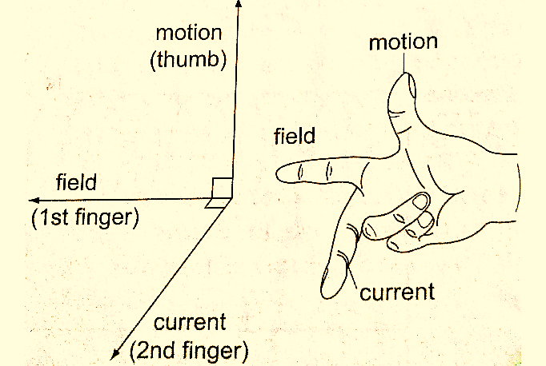

Applications of electromagnetic induction

1. *A.c generator/alternator*– ***a generator is a device which produces electricity on the basis of electromagnetic induction by continuous motion of either a solenoid or a magnet***. It consists of an **armature** made of several turns of insulated wire wound on soft iron core and revolving freely on an axis between the poles of a powerful magnet. Two **slip rings** are connected to the ends of the armature with two **carbon brushes** rotating on the slip ring.

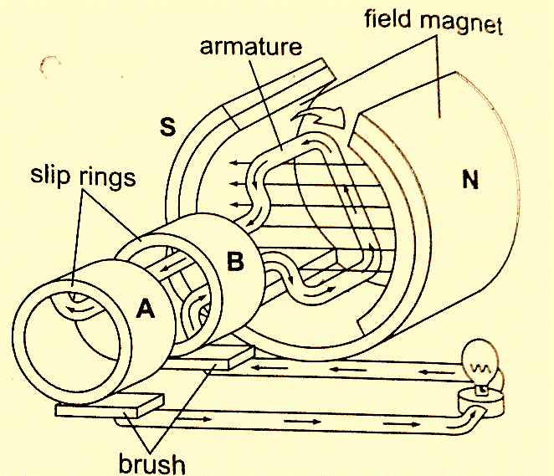

In an external circuit the current is at **maximum value** at **900** and **minimum value** at**2700**. This brings about alternating current and the corresponding voltage (e.m.f) is the alternating voltage. They are used in car alternators and H.E.P.

1. *D.c generator/alternator*– in this case the commutators replaces the slip rings to enable the output to move in one direction. After a rotation of **1800,** instead of current reversing, the connections to the external circuit are reversed so that currentdirection flows in one direction.

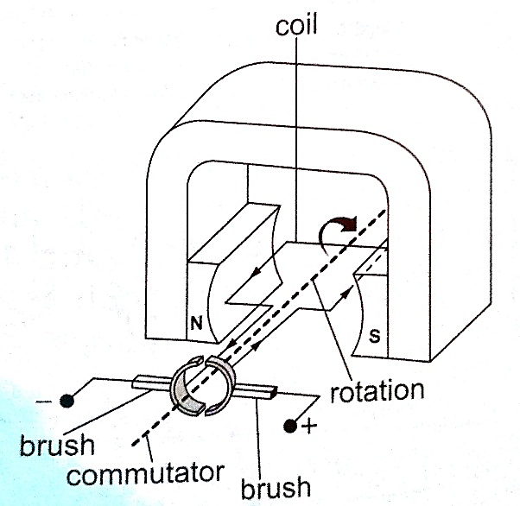

1. *Moving coil microphone*– it consists of a coil wound on a cylindrical cardboard which opens into a diaphragm. The coil is placed between the poles of a magnet as shown.

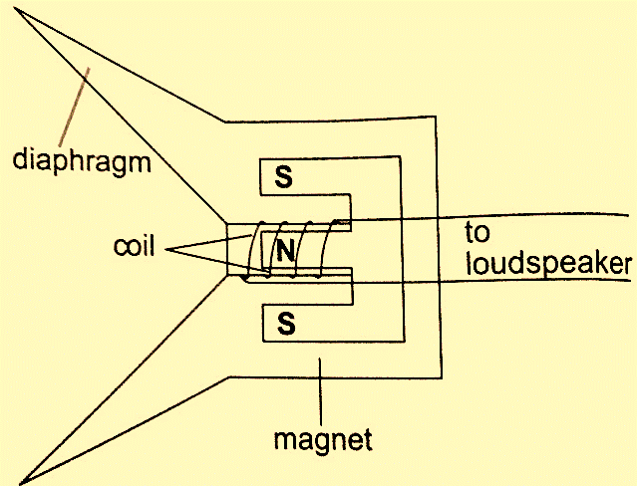

As sound waves hit the diaphragm, they vibrate and move the coil which produces induced current into the coil and then it flows to the loudspeakers.

Eddy currents

They are composed of loops of current which have a magnetic effect opposing the force producing them. When a copper plate with slits is used the loops are cut off and hence the effective currents are drastically reduced and so is the opposing force.

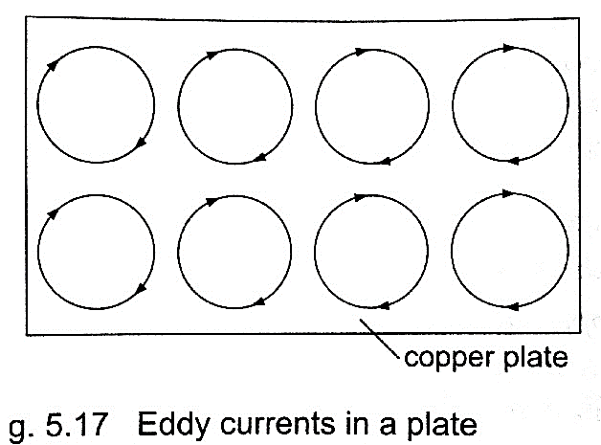

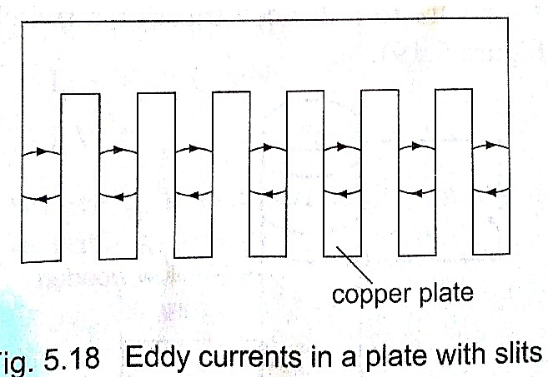

Practically eddy currents are reduced by laminating metal plates. Armatures of electric generators and motors are wound on laminated soft iron cores. The lamination slices, which are quite thin are glued together by a non-conducting glue and this reduces eddy currents to an almost negligible value. Eddy currents are useful in moving coil meters to damp the oscillations of the armature when the current is switched off.

Mutual induction

***Mutual induction is produced when two coils are placed close to each other and a changing current is passed through one of them which in turn produces an induced e.m.f in the second coil***. Therefore mutual induction occurs when a changing magnetic flux in one coil links to another coil.

Applications of mutual induction

1. The transformer- ***it converts an alternating voltage across one coil to a larger or smaller alternating voltage across the other***. Since H.E.P is lost through transmission lines therefore it is stepped down before it being transmitted and stepped up again at the point of supply lines. In a step up transformer the number of turns in the secondary coil **(Ns)** is higher than the number of turns in the primary coil **(Np).** In a step down transformer the primary coil has more turns than the secondary coil. The relationship between the primary voltage and the secondary voltage is given by;

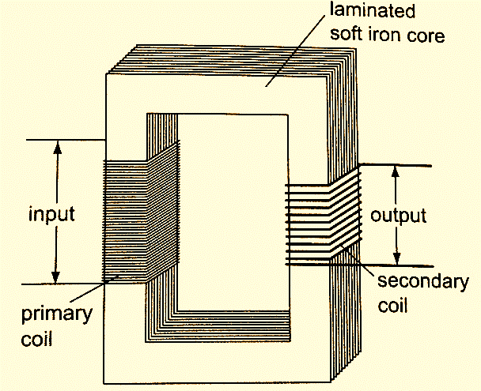**Np / Ns = Vp / Vs.*The efficiency of a transformer is the ratio of power in secondary coil (Ps) to power in primary coil (Pp),*** therefore efficiency **= Ps / Pp × 100%.**

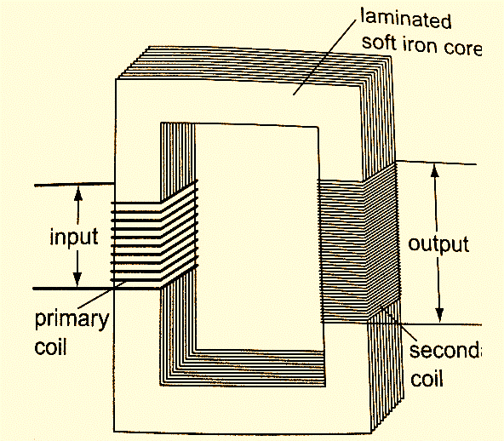

*Step up transformer*

*Step down transformer*

**Examples**

1. *A current of 0.6 A is passed through a step up transformer with a primary coil of 200 turns and a current of 0.1 A is obtained in the secondary coil. Determine the number of turns in the secondary coil and the voltage across if the primary coil is connected to a 240 V mains.*

*Solution*

Np / Ns = Vp / Vs = Ip / Is = Ns = (0.6 × 200) / 0.1 = 1200 turns

Vp = 240 V hence Vs = (240 × 1200) / 200 = 1440 V

1. *A step-up transformer has 10,000 turns in the secondary coil and 100 turns in the primary coil. An alternating current of 0.5 A flows in the primary circuit when connected to a 12.0 V a.c. supply.*
2. *Calculate the voltage across the secondary coil*
3. *If the transformer has an efficiency of 90%, what is the current in the secondary coil?*

*Solution*

1. Vs = (Ns / Np) × Vp = (10,000 × 12) / 100 = 1200 V
2. Power in primary = Pp = Ip × Vp= 5.0 × 12 = 60 W

Efficiency = Ps / Pp × 100% but Ps = Is Vs

Is = (60 × 90) / (1200 × 100) = 0.045 A

*Energy losses in a transformer.*

Loss of energy in a transformer is caused by;

1. *Flux leakage*– this may be due to poor transformer design
2. *Resistance in the windings*–it is reduced by using copper wires which have very low resistance
3. *Hysteresis losses*– caused by the reluctance of the domains to rotate as the magnetic field changes polarity. Reduced by using materials that magnetize and demagnetize easily like soft iron in the core of the transformer.
4. *Eddy currents*– reduced by using a core made of thin, well insulated and laminated sections.

*Uses of transformers*

1. ***Power stations*** *– used to step up or down to curb power losses during transmission*
2. *Supplying low voltages for* ***school laboratories***
3. *Low voltage supply in* ***electronic goods*** *like radios, TVs etc.*
4. *High voltage supply in* ***cathode ray oscilloscope (CRO)*** *for school laboratories.*
5. Induction coil –was developed in **1851** by **Heinrich Ruhmkortt**. It has both secondary and primary coils with an adjustable spark gap.
6. Car ignition system – it is applied in petrol driven engines where a spark plug is used to ignite petrol vapour and air mixture to run the engine.

**CHAPTER SIX**

**MAINS ELECTRICITY**

Sources of mains electricity

Mains electricity comes from a power station and its current is the alternating current which can either be stepped up or down by a transformer. ***A.c is produced when a conductor is rotated in a magnetic field or when a magnetic field is rotated near a conductor.*** This method is known as electromagnetic induction. The source of energy for rotating the turbine is the actual source of electrical energy. Most of the electricity in East Africa is generated from water.

Power transmission

***This is the bulk transfer of electric power from one place to another***. A **power transmission system** in a **country** is referred to as the **national grid**. This transmission grid is a network of power generating stations, transmission circuits and sub-stations. It is usually transmitted in **three phase alternating current**.

*Grid input*

At the generating plant the power is produced at a relatively low voltage of up to **25 kV** then stepped up by the power station transformer up to **400 kV** for transmission. It is transmitted by overhead cables at **high voltage** to minimize energy losses. The cables are made of **aluminium** because it is less dense than copper. Metallic poles (**pylons**) carry four cables, one for each phase and the fourth is the neutral cable which is thinner and completes the circuit to the generator.

*Grid exit*

At sub-stations transformers are used to step down voltage to a lower voltage for distribution to industrial and domestic users. The combination of sub-transmission **(33 kV to 132 kV)** and distribution **(11 kV to 33 kV)** which is then finally transformed to a voltage of **240 V** for domestic use.

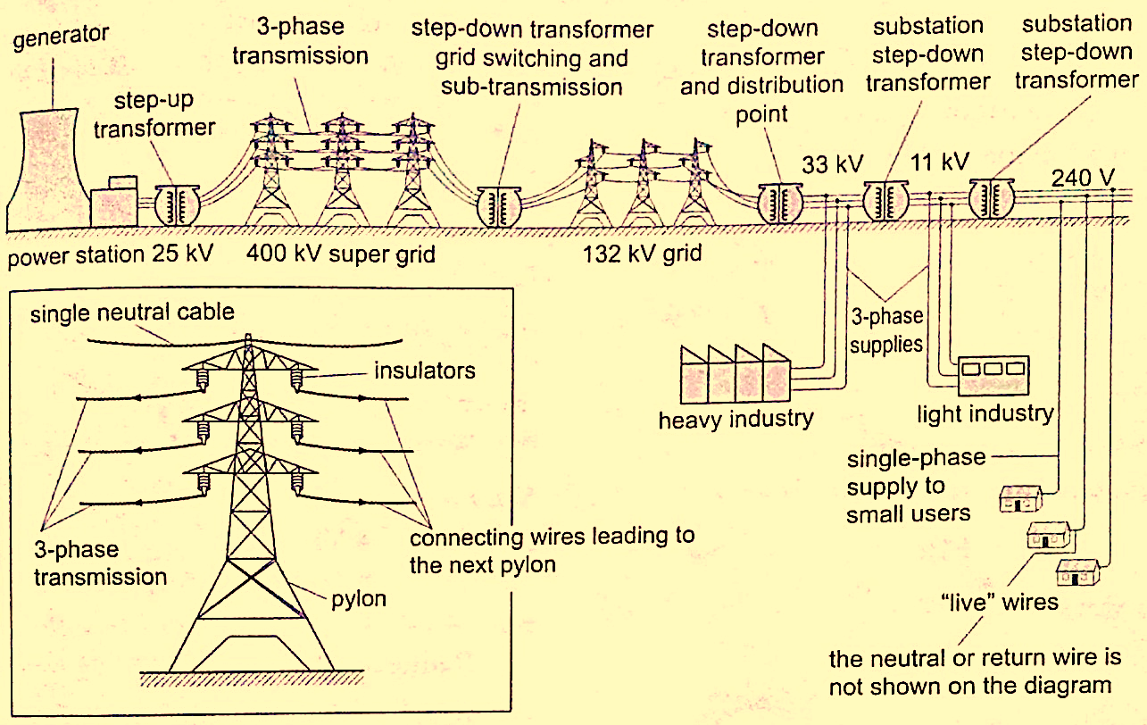

Electricity distribution

***This is the penultimate process of delivery of electric power***. It is considered to include medium voltage (***less than 50 kV***) power lines, low voltage (***less than 1,000 V***) distribution, wiring and sometimes electricity meters.

Dangers of high voltage transmission

1. They can lead to death through electrocution
2. They can cause fires during upsurge
3. Electromagnetic radiations from power lines elevate the risk of certain types of cancer

Electrical power and energy

**Work done = volts × coulombs = VQ,** but **Q = current × time = I t.**

So **work done = V I t**

Other expressions for work may be obtained by substituting **V** and **I** from Ohms law as below

**V = I R** and **I = V / R**, **work done = I R × I t = I2 R t,** or **work done = V × V t / R = V2 t / R**.

The three expressions can be used to calculate work done. Electrical power may be computed from the definition of power. **Power = work / time = I2 R t /t = I2 R or V2 t / R t = V2 / R**

Using **work done = V I t,** then **Power = V I.**

These expressions are useful in solving problems in electricity. Work done or electrical energy is measured in **joules (J)** and power is measured in **watts (W). 1 W = 1 J/s.**

*Example*

*An electric heater running on 240 V mains has a current of 2.5 A.*

1. *What is its power rating?*
2. *What is the resistance of its element?*

*Solution*

1. Power = V I = 240 × 2.5 = 600 W. Rating is 600 W, 240 V.
2. Power = V / R = 600 W. R = V / I. R = 240 / 2.5 = 96 Ω.

Costing electricity

The power company uses a unit called **kilowatt hour (kWh)** which is **the energy transformed by a kW appliance in one hour**. **1 kW = 1,000 W × 60 × 60 seconds = 3,600,000 J**. The meter used for measuring electrical energy uses the kWh as the unit and is known as **joule meter.**

*Examples*

1. *An electric kettle is rated at 2,500 W and uses a voltage of 240 V.*
2. *If electricity costs Ksh 1.10 per kWh, what is the cost of running it for 6 hrs?*
3. *What would be its rate of dissipating energy if the mains voltage was dropped to 120 V?*

*Solution*

1. Energy transformed in 6 hrs = 2.5 × 6 = 15 kWh. Cost = 15 × 1.10 × 6 = Ksh 99.00
2. Power = V2 / R = 2500. R = (240 × 240) /2500 = 23.04 Ω.

Current = V / R = (240 × 2500) / (240 × 240) = 10.42 A

Power = V I = (2500 × 120) / 240 = 1,250 W.

1. *An electric heater is made of a wire of resistance 100 Ω connected to a 240 V mains supply. Determine the;*
2. *Power rating of the heater*
3. *Current flowing in the circuit*
4. *Time taken for the heater to raise the temperature of 200 g of water from 230C to 950C. (specific heat capacity of water = 4,200 J Kg-1 K-1)*
5. *Cost of using the heater for two hours a day for 30 days if the power company charges Ksh 5.00 per kWh.*

*Solution*

1. Power = V2 / R = (240 × 240) / 100 = 576 W
2. P = V I =>> I = P / V = 576 / 240 = 2.4 A
3. P × t = heat supplied = (m c θ) = 576 × t = 0.2 × 4200 × 72.

Hence t = (0.2 × 4200 × 72) / 576 = 105 seconds.

1. Cost = kWh × cost per unit = (0.576 × 2 × 30) × 5.0 = Ksh 172.80
2. *A house has five rooms each with a 60 W, 240 V bulb. If the bulbs are switched on fro 7.00 pm to 10.30 pm, calculate the;*
3. *Power consumed per day in kWh*
4. *Cost per week for lighting those rooms if it costs 90 cents per unit.*

*Solution*

1. Power consumed by 5 bulbs = 60 × 5 = 300 W = 0.3 kWh. Time = 10.30 – 7.00 = 3 ½ hrs.Therefore for the time duration = 0.3 × 3 ½ = 1.05 kWh.
2. Power consumed in 7 days = 1.05 × 7 = 7.35 kWh. Cost = 7.35 × 0.9 = Ksh 6.62

Domestic wiring system

Power is supplied by two cables where one line is live wire **(L)** and the other is neutral **(N).** Domestic supply in Kenya is usually of voltage **240 V**. The current alternates 50 times per second hence the frequency is **50 Hz**. The neutral is earthed to maintain a zero potential. The main fuse is fitted on the live wire to cut off supply in case of a default. **A fuse is a short piece of wire which melts if current of more value flows through it.** Supply to the house is fed to the joule meter which measures the energy consumed. From the meter both L and N cables go to the **consumer box (fuse box)** through the main switch which is fitted on the live cable. Consumer units within the house are fitted with circuit breakers which go off whenever there is a default in the system. Lights in the house are controlled by a single or double switch (two way). In most wiring systems the main sockets are connected to a ring main which is a cable which starts and end at the consumer unit. Plugs used are the three- pin type.

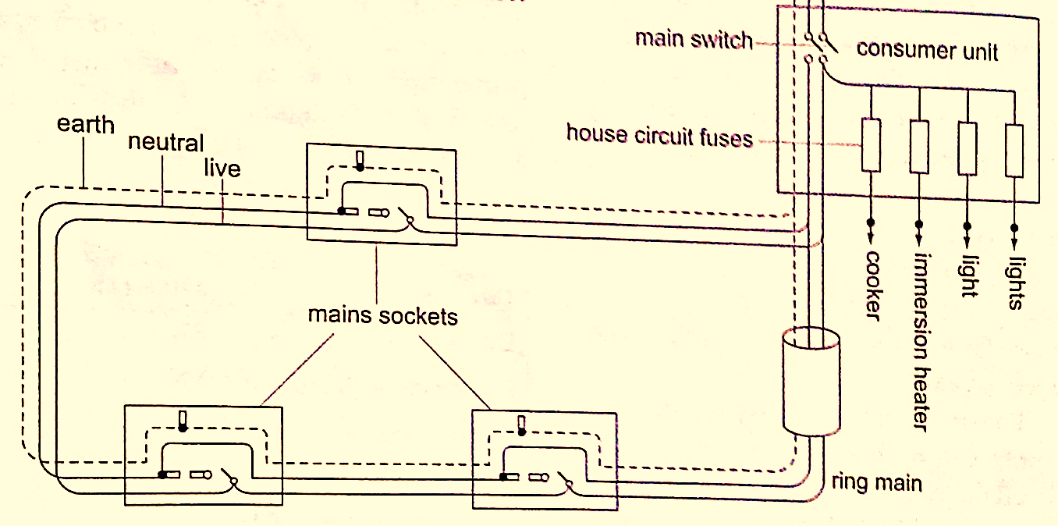

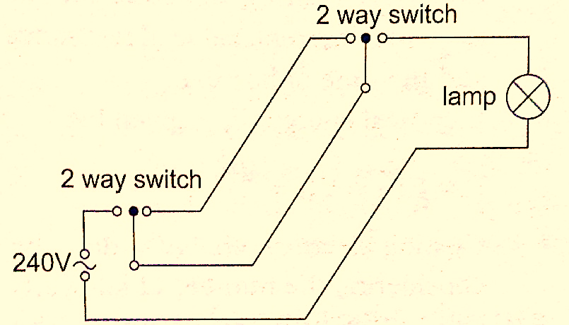

**CHAPTER SEVEN**

**CATHODE RAYS**

***These are streams of electrons emitted at the cathode of an evacuated tube containing an anode and a cathode.***

Production of cathode rays

They are produced by a set up called a discharge tube where a high voltage source usually referred to as **extra high tension (EHT)** supply connected across a tube containing air at low pressure thereby producing a luminous electron discharge between the two brass rods placed at opposite ends of the tube. These electron discharges are called cathode rays which were discovered by **J.J Thomson** in the 18th century.

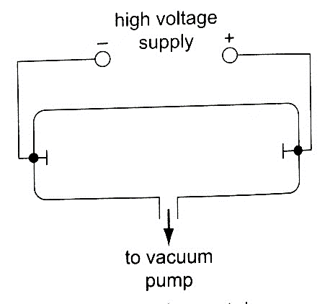

Properties of cathode rays

1. *They travel in straight lines*
2. *They are particulate in nature i.e. negatively charged electrons*
3. *They are affected by both magnetic and electric fields since they are deflected towards the positive plates*
4. *They produce fluorescence in some materials*
5. *Depending on the energy of the cathode rays they can penetrate thin sheets of paper, metal foils*
6. *When cathode rays are stopped they produce X-rays.*
7. *They affect photographic plates.*

Cathode ray oscilloscope (CRO)

It is a complex equipment used in displaying waveforms from various sources and measuring p.d. It comprises of the following main components; - The **cathode ray tubes (CRT)** – **consists of a tube, electron gun, deflection plates and the time base (TB).** The tube is made of strong glass to withstand the pressure difference between the outside atmospheric pressure and the vacuum inside. It has a square grid placed in front of it to allow measurements to be made. The **electron gun** produces the electrons with main parts consisting of a **filament, a cathode, a grid and the anode**. Electrons are produced by the cathode when heated by the filament. The grid is a control electrode which determines the number of electrons reaching the screen therefore determining the brightness of the screen. The Y-deflection plates deflects the beam up or down. Clearly observable when low frequency inputs are applied i.e. **10 Hz** from a signal operator. The X-deflection plates are used to move the beam left or right of the screen at a steady speed using the time base circuit which automatically changes voltage to an a.c. voltage. 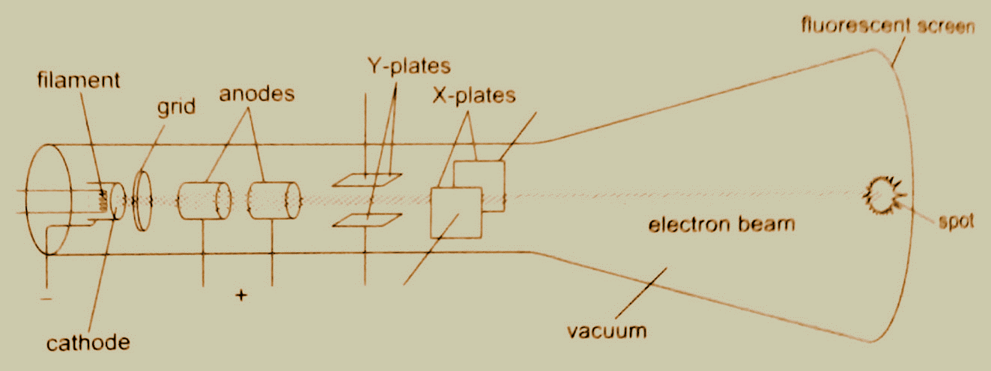When time base control is turned the speed can be adjusted to produce a waveform.

*Examples*

1. *If the time base control of the CRO is set at 10 milliseconds per cm, what is the frequency of the wave traced given wavelength as 1.8 cm?*

*Solution*

Wavelength = 1.8 cm. time for complete wave = period = 1.8 × 10 milliseconds / cm

= 18 milliseconds

= 1.8 × 10-2 seconds.

Frequency ‘f’, is given by f = 1 / T = 1 / 1.8 × 10-2 = 100 / 1.8 = 56 Hz.

**NOTE: -**

The television set **(TV)** is a type of a **CRT** with both Y and X-deflection plates which control the formation of a picture (motion) on the screen. The colour television screen is coated with different **phosphor dots** (chemicals) which produce a different colour when struck by an electron beam.

**CHAPTER EIGHT**

**X-RAYS**

X-rays were discovered by a **German scientist** named**Roentgen** in 1985. They can pass through most substances including soft tissues of the body but not through bones and most metals. They were named X-rays meaning 'unknown rays'.

X-ray production

They are produced by modified discharge tubes called X-ray tubes. The cathode is in the form of a filament which emits electrons on heating. The anode is made of solid copper molybdenum and is called the target. A high potential difference between the anode and the cathode is maintained (10,000 v to 1,000,000 or more) by an external source. The filament is made up of tungsten and coiled to provide high resistance to the current. The electrons produced are changed into x-rays on hitting the anode and getting stopped. Only 0.2% of the energy is converted into x-rays. Cooling oil is led in and out of the hollow of the anode to maintain low temperature. The lead shield absorbs stray x-rays.

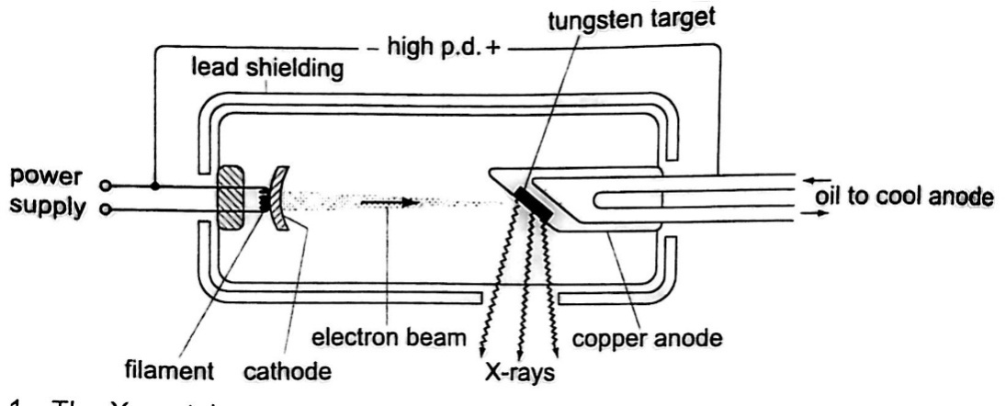

Energy changes in an X-ray tube.

When the cathode is heated electrons are emitted by thermionic emission. They acquire electrical energy which can be expressed as **E = e V.** Once in motion the electrical energy is converted to kinetic energy, that is **eV = ½ me v2.**

The energy of an electromagnetic wave can be calculated using the following equation

**Energy = h *f*,***where* **h***- Planck’s constant,* ***f*** *– frequency of the wave*.

The highest frequency of the X-rays released after an electron hits the target is when the greatest kinetic energy is lost, that is ***h f max = eV.***

Lower frequencies are released when the electrons make multiple collisions losing energy in stages, the minimum wavelength, **λ min**, of the emitted X-rays is given by;

**(*hc*) / λ min = eV.**

These expressions can be used to calculate the energy, frequencies and wavelengths of X-rays.

***Examples***

1. *Determine the energy possessed by X-rays whose frequency is 4 × 1017 Hz.*

Solution

E = *h f =*> 6.63 × 10-34 ×4 × 1017 = 2.652 × 10-16 J.

1. *An x-ray tube operates at 60 kV and the current through it is 4.0 mA. Calculate the,*
2. *Number of electrons striking the target per second.*
3. *Speed of the electrons when they hit the target.*

Solution

1. Current through the tube is given by **I = *ne****, where n- number of electrons striking target per second and e- electronic charge ( e = 1.6 × 10-19coulombs)*

So, n = 1/e = (4.0 × 10-3) / 1.6 × 10-19 = 2.5 × 1016 electrons.

1. Kinetic energy = electrical energy

½ me v2 = eV, then v = 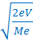 = 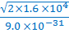 = 2.13 × 108 m/s.

1. *An 18 kV accelerating voltage is applied across an X-ray tube. Calculate;*
2. *The velocity of the fastest electron striking the target*
3. *The minimum wavelength in the continuous spectrum of X-rays produced. (****mass of electron-9 × 10-31 kg, charge on an electron-1.6 × 10-19 C, h- 6.6 × 10-34 J/s, c- 3 × 108 m/s)***

Solution

1. V = 18 × 103 V

me = 9 × 10-31 kg

e = 1.6 × 10-19 C

h = 6.6 × 10-34 J/s

c = 3 × 108 m/s

½ me v2 = e v; therefore v = 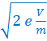 = 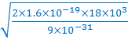 = 8 × 107 m/s’

1. (*h c*) / λ min = eV; λ min = hc / eV

λ min = (6.6 × 10-34× 3 × 108 ) / (1.6 × 10-19× 18 × 103) = 6.9 × 10-11 m.

Properties of X-rays

1. They travel in straight lines
2. They undergo reflection and diffraction
3. They are not affected by electric or magnetic fields since they are not charged particles.
4. They ionize gases causing them to conduct electricity
5. They affect photographic films
6. They are highly penetrating, able to pass easily through thin sheets of paper, metal foils and body tissues
7. They cause fluorescence in certain substances for example barium platinocynide.

Hard X-rays

These are x-rays on the lower end of their range **(10-11 – 10-8 m)** and have more penetrating power than normal x-rays. They are capable of penetrating flesh but are absorbed by bones.

Soft X-rays

They are on the upper end of the range and are less penetrative. They can only penetrate soft flesh and can be used toshow malignant growth in tissues.

Dangers of X-rays and the precautions.

1. They can destroy or damage living cells when over exposed.
2. Excessive exposure of living cells can lead to genetic mutation.
3. As a precautionary measure X-ray tubes are shielded by lead shields.

Uses of X-rays

1. *Medicine* – X-ray photos called radiographs are used as diagnostic tools for various diseases. They are also used to treat cancer in radiotherapy.
2. Industry – they are used to photograph and reveal hidden flaws i.e. cracks in metal casting and welded joints.
3. Science – since the spacing of atomic arrangement causes diffraction of x-rays then their structure can be studied through a process called X-ray crystallography.
4. *Security* – used in military and airport installations to detect dangerous metallic objects

i.e. guns, explosives, grenades etc.

**CHAPTER NINE**

**PHOTOELECTRIC EFFECT**

Photoelectric effect was discovered by **Heinrich Hertz** in **1887**. ***Photoelectric effect is a phenomenon in which electrons are emitted from the surface of a substance when certain electromagnetic radiation falls on it***. Metal surfaces require ultra-violet radiation while caesium oxide needs a visible light i.e. optical spectrum (sunlight).

Work function

A minimum amount of work is needed to remove an electron from its energy level so as to overcome the forces binding it to the surface. This work is known as the work function with units of **electron volts (eV**). **One electron volt is the work done when one electron is transferred between points with a potential difference of one volt**; that is,

**1 eV = 1 electron × 1 volt**

**1 eV = 1.6 × 10-19 × 1 volt**

**1 eV = 1.6× 10-19 Joules (J)**

Threshold frequency

***This is the minimum frequency of the radiation that will cause a photoelectric effect on a certain surface***. The higher the work function, the higher the threshold frequency.

Factors affecting the photoelectric effect

1. *Intensity of the incident radiation*– the rate of emission of photoelectrons is directly proportional to the intensity of incident radiation.
2. *Work function of the surface*– photoelectrons are emitted at differentvelocities with the maximum being processed by the ones at the surface.
3. *Frequency of the incident radiation*– the cut-off potential for each surface is directly proportional to the frequency of the incident radiation.

Planck’s constant

When a bunch of oscillating atoms and the energy of each oscillating atom is quantified i.e. it could only take discrete values. Max Planck’s predicted the energy of an oscillating atom to be

**E = n h *f****, where* ***n*** *– integer,* ***f*** *– frequency of the source,* ***h*** *– Planck’s constant which has a value of* ***6.63 × 10-34 Js.***

Quantum theory of light

Planck’s published his quantum hypothesis in **1901** which assumes that the transfer of energy between light radiation and matter occurs in discrete units or packets. Einstein proposed that light is made up of packets of energy called photons which have no mass but they have momentum and energy given by;

***E = h f***

The number of photons per unit area of the cross-section of a beam of light is proportional to its intensity. However the energy of a photon is proportional to its frequency and not the intensity of the light.

Einstein’s photoelectric equation

As an electron escapes energy equivalent to the work function **‘Φ’** of the emitter substance is given up. So the photon energy ‘**h *f’*** must be greater than or equal to **Φ.** If the ‘**h *f*’** is greater than **Φ** then the electron acquires some kinetic energy after leaving the surface. The maximum kinetic energy of the ejected photoelectron is given by;

**K.E max = ½ m v2max = h *f* – Φ ……………… (i),** *where* ***m v2max*** *= maximum velocity and mass.*

***This is the Einstein’s photoelectric equation****.*

If the photon energy is just equivalent to work function then, **m v2max = 0**, at this juncture the electron will not be able to move hence no photoelectric current, giving rise to a condition known as c**ut-off frequency**, **h *f*co  = Φ………………. (ii)**

Also **the p.d required to stop the fastest photoelectron is the cut-off potential**, **V co**which is given by **E = e V co** electron volts, but this energy is the maximum kinetic energy of the photoelectrons and therefore, **½ m v2max = e V co ………….. (iii).**

Combining equations (i), (ii) and (iii), we can write Einstein’s photoelectric equation as,

**e V co  = h *f* – h *f*co ………………….. (iv)**

**NOTE:** -- Equations **(i)** and **(iv)** are quite useful in solving problems involving photoelectric effect.

*Examples*

1. *The cut-off wavelength for a certain material is 3.310 × 10-7 m. What is the cut-off frequency for the material?*

Solution

Speed of light ‘c’ = 3.0 × 108 m/s. Since *f* = c / λ, then

f = 3.0 × 108 / 3.310 × 10-7 = 9.06 × 1014 Hz.

1. *The work function of tungsten is 4.52 e V. Find the cut-off potential for photoelectrons when a tungsten surface is illuminated with radiation of wavelength 2.50 × 10-7 m. (Planck’s constant, h = 6.62 × 10-34 Js).*

Solution

Frequency ‘*f’* = c / λ = 3.0 × 108 / 2.50 × 10-7.

Energy of photon = h f = 6.62 × 10-34 × (3.0 × 108 / 2.50 × 10-7) × (1 / 1.6 × 10-19)

= 4.97 eV.

Hence h *f*co = 4.52 e V. e V co = 4.97 e V - 4.52 e V = 0.45 e V = 7.2 × 10-20 J

V co = 7.2 × 10-20 / 1.6 × 10-19 = 0.45 e V.

1. *The threshold frequency for lithium is 5.5 × 1014 Hz. Calculate the work function for lithium. (Take ‘h’ = 6.626 × 10-34 Js)*

Solution

Threshold frequency, *f* o = 5.5 × 1014 Hz, ‘h’ = 6.626 × 10-34 Js

Φ = h f = 5.5 × 1014× 6.626 × 10-34 = 36.4 × 10-20

1. *Sodium has a work function of 2.0 e V. Calculate*
2. *The maximum energy and velocity of the emitted electrons when sodium is*

*Illuminated by a radiation of wavelength 150 nm.*

1. *Determine the least frequency of radiation by which electrons are emitted.*

*(Take ‘h’ = 6.626 × 10-34 Js, e = 1.6 × 10-19, c = 3.0 × 108 m/s and mass of electron*

*= 9.1 × 10-31 kg).*

Solution

1. The energy of incident photon is given by h *f* = c / λ

= (6.626 × 10-34 *×* 3.0 × 108) / 1.50 × 10-9 = 1.325 × 10-18 J

K.E max = h f – Φ = (1.325 × 10-18) – (2 × 1.6 × 10-19) = 1.0 × 10 -18 J *(max. K.E of the*

*emitted electrons)*

But K.E max = ½ m v2max. Therefore;

1.0 × 10 -18 = ½ × 9.1 × 10-31 × V2max

V2max = (1.0 × 10 -18 / 9.1 × 10-31)1/2 = 1.5 × 106 m/s (*max. velocity of emitted*

*electrons).*

1. Φ = h *f* co and *f* o = Φ / λ, Φ = 2 × 1.6 × 10-19

*f*o = (2 × 1.6 × 10-19) / (6.626 × 10-34) = 4.8 × 1014 Hz (*min. threshold frequency of*

*the emitted electrons)*

Applications of photoelectric effect

1. *Photo-emissive cells*– they are made up of two electrodes enclosed in a glass bulb (evacuated or containing inert gas at low temperature). The cathode is a curved metal plate while the anode is normally a single metal rod)

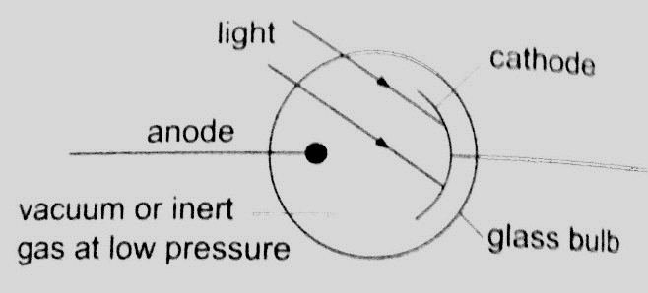

They are used mostly in controlling lifts (doors) and reproducing the sound track in a film.

Photoconductive cells – some semi-conductors such as **cadmium sulphide (cds)** reduces their resistance when light is shone at them **(photo resistors).** Other devices such as photo-diodes and photo-transistors block current when the intensity of light increases.

Photo-conductive cells are also known as **light dependent resistors (LDR)** and are used in alarm circuits i.e. fire alarms, and also in cameras as exposure metres.

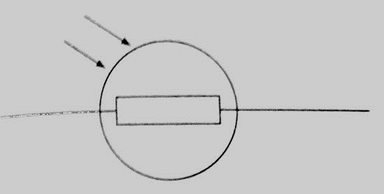

1. *Photo-voltaic cell*– this cell generates an e.m.f using light and consists of a copper disc oxidized on one surface and a very thin film of gold is deposited over the exposed surfaces (this thin film allows light). The current increases with light intensity.

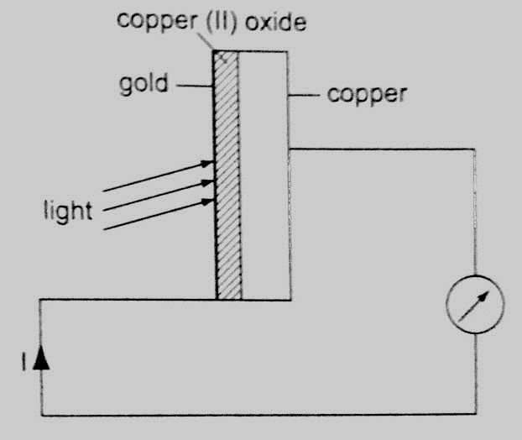

They are used in electronic calculators, solar panels etc.

**CHAPTER TEN**

**RADIOACTIVITY**

Introduction

Radioactivity was discovered by **Henri Becquerel** in **1869**. In **1898**, **Marie** and **Pierre Curie** succeeded in chemically isolating two radioactive elements, **Polonium** (z=84) and **Radium** (z= 88). ***Radioactivity or radioactive decay is the spontaneous disintegration of unstable nuclides to form stable ones with the emission of radiation. Unstable nuclides continue to disintegrate until a stable atom is formed.*Alpha (α)** and **beta (ϐ)** particles are emitted and the **gamma rays** (**ϒ)** accompany the ejection of both alpha and beta particles.

The nucleus

The nucleus is made up of **protons** and **neutrons**. They are surrounded by negatively charged ions known as **electrons**. The number of protons is equal to the number of electrons. Both protons and neutrons have the same mass. The weight of an electron is relatively small compared to neutrons and protons. **The number of protons in an atom is referred to as the proton number (atomic number) and denoted by the symbol Z**. the number of neutrons is denoted by the symbol **N**. Protons and neutrons are called **nucleons** since they form the nucleus of an atom. The **sum** of both the **protons** and **neutrons** is called the **mass number A** or **nucleon number**. Therefore;

**A = Z + N** and **N = A – Z.**

The masses of atoms are conveniently given in terms of **atomic mass units (ᴜ)** where (ᴜ) is 1/12th the mass of one atom of carbon-12 and has a value of **1.660 × 10-27 kg**. Hence the mass of **one proton** is equal to **1.67 × 10-27** and is equal to **1ᴜ.**

Radioactive isotopes

***Isotopes are elements with different mass numbers but with equal atomic numbers*** i.e. uranium with mass numbers 235 and 238.

Properties of radioactive emissions

1. *Alpha (α) particles*

They are represented as, hence with a nucleus number 4 and a charge of +2.

*Properties*

1. *Their speeds are 1.67 × 107 m/s, which is 10% the speed of light.*
2. *They are positively charged with a magnitude of a charge double that of an electron.*
3. *They cause intense ionization hence loosing energy rapidly hence they have a very short range of about 8 cm in air.*
4. *They can be stopped by a thin sheet of paper, when stopped they capture two electrons and become helium gas atoms*
5. *They can be affected by photographic plates and produce flashes when incident on a fluorescent screen and produce heating effect in matter.*
6. *They are slightly deflected by a magnetic field indicating that they have comparatively large masses.*
7. *Beta (ϐ) particles*

They are represented by meaning that they have no mass but a charge of -1.

*Properties*

1. *Their speeds are as high as 99.9% or more the speed of light*
2. *They are deflected by electric and magnetic fields but in a direction opposite to that of alpha particles.*
3. *Due to their high speed they have a higher penetrative rate than alpha particles (about 100 times more)*
4. *They can be stopped by a thin sheet of aluminium*
5. *Their ionization power is much less intense about 1/100th that of alpha particles.*
6. *Gamma (ϒ) particles*

They have very short wavelengths in the order of 10-10 m and below.

*Properties*

1. *They travel at the speed of light.*
2. *They have less ionization power than that of both alpha and beta particles*
3. *They accompany the emission of alpha and beta particles*
4. *They carry no electric charge hence they are not deflected by both electric and magnetic fields.*
5. *They have more penetrating power than X-rays.*

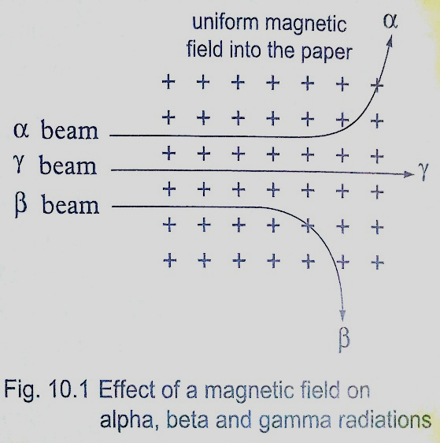

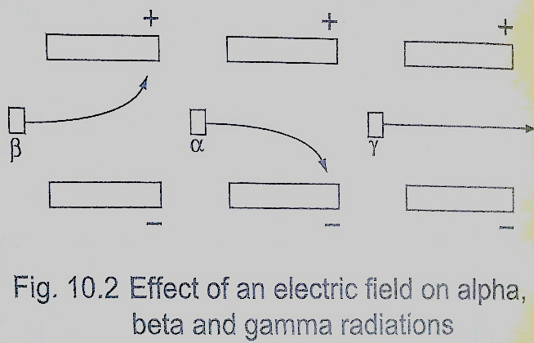

Detecting nuclear radiation

1. *Gold leaf electroscope*–the rate of collapse of the leaf depends on the nature and intensity of radiation. The radioactive source ionizes the air around the electroscope. Beta particles discharges a positively charged electroscope with the negative charge neutralizing the charge of the electroscope. Alpha particles would similarly discharge a negatively charged electroscope. To detect both alpha and beta particles a charged electroscope may not be suitable because their ionization in air may not be sufficiently intense making the leaf not to fall noticeably.

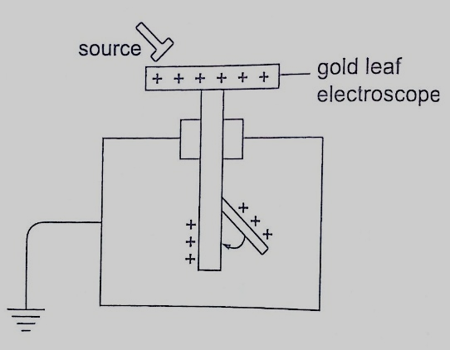

1. *The spark counter* – the detector is shown below

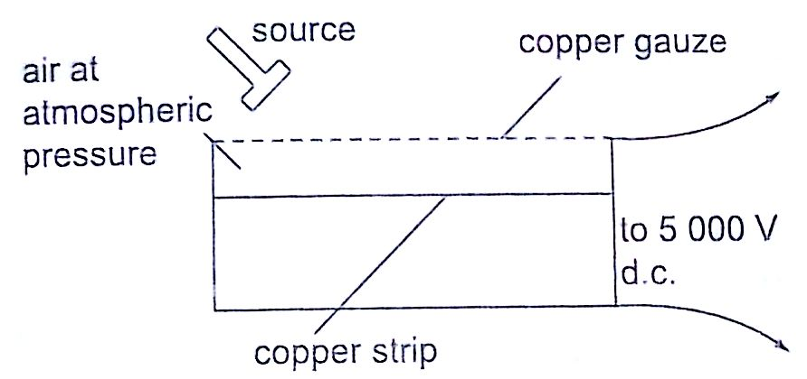

This detector is suitable for alpha sources due to the inadequacy of the ionization by both beta and gamma radiations. By putting the source away from the gauze or placing a sheet of paper between the two one can determine the range and penetration of the alpha particles.

1. *Geiger Muller (GM) tube*– it is illustrated as below

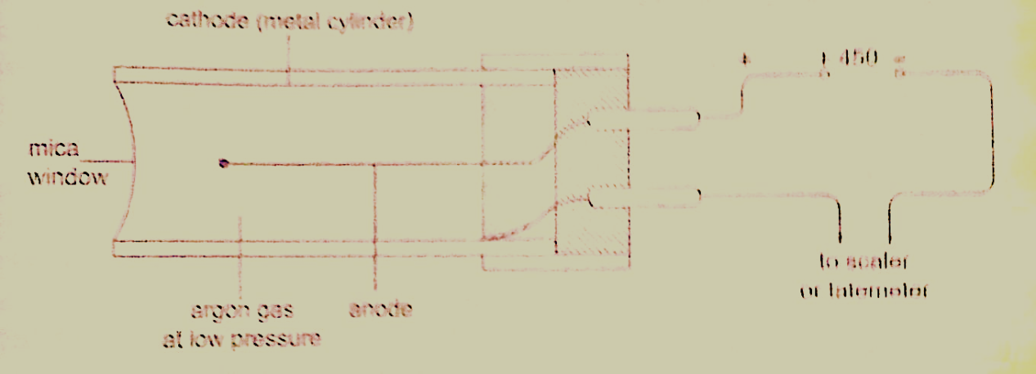

The mica window allows passage of alpha, beta and gamma radiations. The radiations ionize the gas inside the tube. The electrons move to the anode while the positive ions move to the cathode. As the ions are produced there are collisions which produce small currents which are in turn amplified and passed to the scale. The scale counts the pulses and shows the total on a display screen. After each pulse the gas returns to normal ready for the next particle to enter. A small presence of halogen gas in the tube helps in absorbing the positive ions to reduce further ionization and hence a quick return to normal. This is called quenching the tube.

1. *The solid state detector*– this detector can be used to detect alpha, beta and gamma radiations where the incoming radiation hits a **reverse biased p-n junction diode** momentarily conducting the radiation and the pulse of the current is detected using a scaler.
2. *The diffusion cloud chamber*– this chamber is simplified as shown below

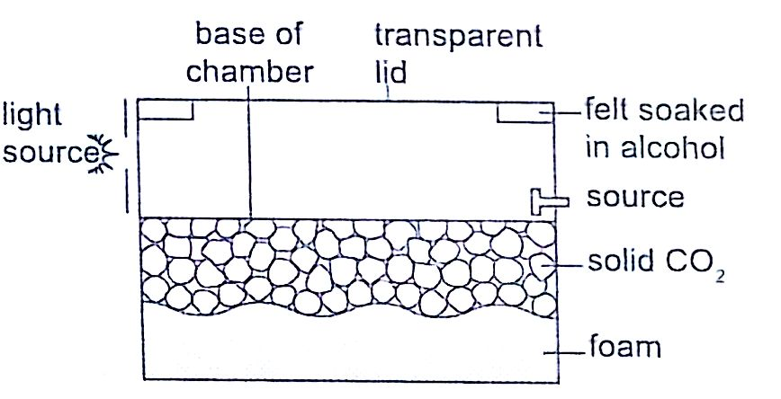

The bottom of the chamber is cooled by **solid carbon (V) oxide** to around **-800 C** and the alcohol vapour from the felt ring spreads downwards. It is cooled below its normal condensing temperature. As a particle enters the chamber it ionizes the air in its path and alcohol condenses around the path to form millions of tiny alcohol droplets leaving a trail visible because it reflects light from the source. **Alpha particles** leave **a thick, short straight tracks**. **Beta particles** leave **thin irregular track**s. **Gamma particles** do **not produce tracks** and since they eject electrons from atoms the tracks are similar to those of beta particles.

Activity and half-life of elements

**The activity of a sample of radioactive element is the rate at which its constituent nuclei decay or disintegrate**. It is measured in **disintegrations per second or Curie (Ci) units**, where

**1 Ci = 3.7 × 1010 disintegrations per second**

**1 micro Curie (µ C) = 3.7 × 104 disintegrations per second.**

The **law of radioactive decay** states that **“the activity of a sample is proportional to the number of undecayed nuclei present in the sample**”. *The half-life of a radioactive element is the time required for its one-half of the sample to decay*. It is important to note that although the activity approaches zero, it never goes to zero.

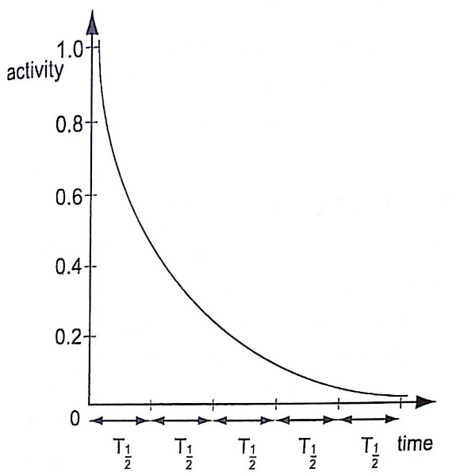

*Examples*

1. *The half-life of a sample of a radioactive substance is 98 minutes. How long does it take for the activity of the sample to reduce to 1/16th of the original value?*

Solution

Time (minutes) Activity

0 1

98 ½

196 ¼

294 1/8

392 1/16 =>> time taken = 392 minutes.

1. *An isotope has a half-life of 576 hours. Complete the following table and show how mass varies with time from an initial mass of 1280 g?*

|  |  |  |  |  |
| --- | --- | --- | --- | --- |
| *Time (hrs)* | *576* | *1152* | *1728* | *2304* |
| *Mass (g)* | *640* |  |  |  |

Solution

1152 ------ 320 g

1728 ------ 160 g

2304 ------ 80 g.

1. *The initial number of atoms in a sample is 5.12 × 1020. If the half-life of the sample is 3.0 seconds, determine the number of atoms that will have decayed after six seconds.*

Solution

After the first half-life, then ½ (5.12 × 1020) = 2.56 × 1020 will have decayed.

The second half-life, then ½ (2.56 × 1020) = 1.28 × 1020 will have decayed.

The total number of decayed atoms = (2.56 + 1.28) × 1020 = 3.84 × 1020 atoms.

1. *A radioactive element has an initial count rate of 2,400 counts per minute on a scaler. The count rate falls to 300 units per minute in 30 hours,*
2. *Calculate the half-life of the element*
3. *If the initial number of atoms in another sample of the same element is 6.0 × 1020, how many atoms will have decayed in 50 hours?*

Solution

1. 2,400 × ½ × ½ × ½ = 300

Three half-lives have a total of 30 hours, thus half-life = 30 /3 = 10 hours

1. Since half-life = 10 hrs half-lives in 50 hrs = 50/10 = 5 hrs.

So the remaining undecayed atoms are ½ × ½ × ½ × ½ × ½ × 6.0 × 1020

= 0.1875 × 1020, thus

The number of atoms which have decayed = (6.0 – 0.1875) × 1020

= 5.812 × 1020

Nuclear equations

Particles making an atom can be written using upper and lower subscripts where a proton, **‘p’** with charge **+1** and mass **1ᴜ**, is written as***.*** A neutron **‘n’** with no charge but with mass **1ᴜ,** is written as**,** while an electron with a charge of **-1** and negligible mass is written as**.** It is important to note that the principles of conservation apply in radioactive decay. That means that the total number of nucleons (neutrons + protons) must be the same before and after decay. The L.H.S of the equation must be equal to the R.H.S for both total mass and charge.

Effects of radioactive decay on the nucleus

*Alpha decay*

A nucleus emitting an alpha particle reduces its mass by 4 atomic mass units and its proton number by 2. The equation can be written as follows,

 **----------à** **+ α** or **----------à** **+** 

*Example*

*Uranium- 235 (**) changes to Thorium (**) by emitting an alpha particle. Write a nuclear equation to represent the decay.*

Solution

 --------à + 

***The change of an element (nucleus) to another is called transmutation.***

*Beta decay*

The beta particle is an electron. Beta particles are produced by changing a neutron to a proton and later to an electron as shown,

 **--------à** ***+*** 

The electron is then ejected from the nucleus and the number of protons increases by 1 while the mass number remains the same (an electron is of negligible mass).

 **----------à** **+**

***Examples***

1. *Thorium**) changes to Proctanium (Po) with the emission of a beta particle. Show the decay using nuclear equation.*

Solution

 ----------ào + 

1. *Write an equation to show how a radioactive isotope of cobalt (**o) undergoes a beta decay followed by the emission of gamma rays to form a new nuclide X.*

Solution

o -------àϐ + ϒ +  or o + +ϒ +

1. *A radioactive carbon-14 decays to nitrogen by emitting a beta particle as shown. Determine the values of ‘x’ and ‘y’ in the equation below.*

 *------à* *+* 

Solution

X + 0 = 14 hence x = 14

7 + y =6 hence y = -1

Other examples

*Balance the following equations*

1.  --------à Y +  + α
2.  --------à + 2α
3.  ---------à + ---------
4. ---------à + -------

*Solutions*

1.  *--------à* *+*  *+* 
2.  *--------à* *+ 2*
3.  *---------à* *+* 
4. *---------à* *+* 

Nuclear fission

***Nuclear fission is a process in which a nucleus splits into two or more lighter nuclei***. This process generates large amounts of energy together with neutron emission. Nearly 80% of the energy produced appears as kinetic energy of the fission fragments. For example **Uranium-235** undergoes nuclear fission when bombarded with slow neutrons releasing **2-3 neutrons** per Uranium molecule and every neutron released brings about the fission of another Uranium-235nuclei. Another substance which undergoes the same process is **Plutonium-239**. **Substances** which **undergo fission directly** with slow neutrons are known as **fissile substances or isotopes**.

*Applications of nuclear fission*

1. *They are used in the manufacture of atomic bombs where tremendous amount of energy is released within a very short time leading to an explosion.*
2. *When this release of energy is controlled such that it can be released at a steady rate then it is converted into electrical energy hence the principle in nuclear reactors.*

Nuclear fusion

**Nuclear fusion is the thermal combining of light elements to form relatively heavier nuclei**. The process requires very high temperatures for the reacting nuclei to combine upon collision. These temperatures are provided by ordinary fission bombs. These reactions sometimes known as **thermonuclear reactions**. A fusion reaction releases energy at the rate of **3-23 MeV** per fusion event i.e. two deuterium (heavy hydrogen) nuclei to form helium.

 **+**  **------à** **+**  **+ 3.3 MeV (energy).**

This 3.3 MeV (energy) produced is equal to **5.28 × 10-13 J**.

*Application of nuclear fusion*

1. *Used in the production of hydrogen bomb. Possible reactions for an hydrogen bomb include;*

 *+*  *------à* *+*  *+ 17.8 + 22.4 MeV*

 *+*  *------à* *+ 17.8 + 20.0 MeV*

Hazards of radioactivity and their precautions

1. *Due to the ionizing radiation emitted by radiation materials, they affect living cells leading to serious illnesses. Symptoms of radiation exposures are immature births, deformations, retardedness, etc.*
2. *Their exposure to the environment through leaks may lead to environmental pollution leading to poor crop growth and destruction of marine life.*

Applications of radioactivity

1. *Carbon dating – through the identification of carbon-14 and carbon-12 absorbed by dead plants and animals. Scientists can be able to estimate the age of a dead organism. Since carbon is a radioactive element with a half-life of 5,600 years archeologists can be able to estimate the ages of early life through carbon dating.*
2. *Medicine – radiation is used in the treatment of cancer, by using a radioactive cobalt-60 to kill the malignant tissue. Radiations are used in taking x-ray photographs using cobalt-60. Radiations are used to sterilize surgical instruments in hospitals. Radioactive elements can also be used as tracers in medicine where they determine the efficiency of organisms such as kidneys and thyroid glands.*
3. *Biology and agriculture – radioactive sources are used to generate different species of plants with new characteristics that can withstand diseases and drought. Insects are sterilized through radiation to prevent the spread of pests and diseases. Potatoes exposed to radiation can be stored for a long time without perishing.*
4. *Industry – thickness of metal sheets is measured accurately using radiation from radioactive sources. Recently the manufacture of industrial diamonds is undertaken through transmutation.*
5. *Energy source – in N. America, Europe and Russia nuclear reactors are used to generate electricity. The amount of fuel used is quite small hence an economical way of generating electricity energy as compared to H.E.P generation.*

**CHAPTER ELEVEN**

**ELECTRONICS**

Conductors, insulators and semi-conductors

1. An insulator **is a material or object which resists flow of heat (thermal insulator) or electrical charges (electrical insulators**). Examples are paraffin, wood, rubber, plastics etc.
2. Conductors**are materials that contain free electrons which carry an electrical charge from one point to another**. Examples are metals and non-metals like carbon, graphite etc.
3. Semi-conductors **are materials or objects which allow the flow of electrical heat or energy through them under certain conditions** i.e. temperature. Examples are germanium, silicon, cadmium sulphide, gallium arsenide etc.

Electronic bond structure

This is the series of “**allowed”** and “**forbidden”** energy bands that it y bands that it contains according to the band theory which postulates the existence of continuous ranges of energy values (bands) which electron may occupy **“allowed”** or not occupy **‘forbidden”.** According to **molecular orbital theory**, if several atoms are brought together in a molecule, their atomic orbitals split, producing a number of molecular orbitals proportional to the number of atoms. However when a large number of atoms are brought together the difference between their energy levels become very small, such that some intervals of energy contain no orbitals and this theory makes an assumption that these energy levels are as numerous as to be indistinct.

*Number, size and spacing of bands.*

Any solid has a large number of bands **(theoretically infinite).** Bands have different widths based upon the properties of the atomic orbitals from which they arise. Bands may also overlap to produce a bigger single band.

*Valence and conduction bands*

**Valence band is the highest range of electron energies where electrons are normally present at zero temperature**. Conduction band is the range of electron energy higher than that of the valence band sufficient to make **electrons free (delocalized)**; responsible for transfer of electric charge. Insulators and semi-conductors have a gap above valence band followed by conduction band above it. In metals, the conduction band is the valence band.

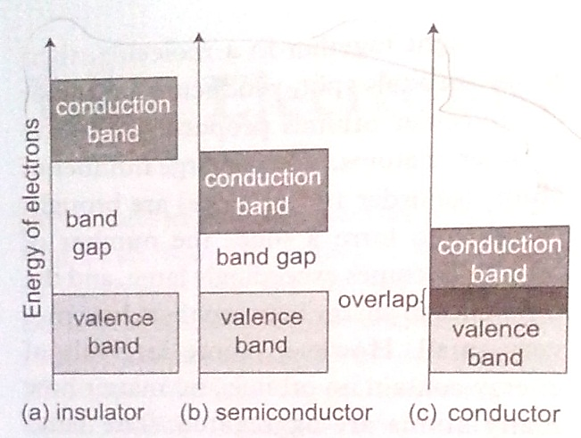

Band structure of a semi-conductor.

Electrons in the conduction band break free of the covalent bonds between atoms and are free to move around hence conduct charge. The covalent bonds have missing electrons or ‘holes’ after the electrons have moved. The current carrying electrons in the conduction band are known as free electrons.

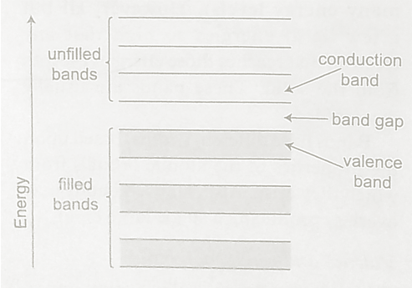

Doping of semi-conductors

**Doping is the introduction of impurities in semi-conductors to alter their electronic properties.** The impurities are called **dopants**. Doping heavily may increase their conductivity by a factor greater than a million.

Intrinsic and extrinsic semi-conductors

**An intrinsic semi-conductor is one which is pure enough such that the impurities in it do not significantly affect its electrical behavior**.Intrinsic semi-conductors increase their conductivity with increase in temperature unlike metals.An extrinsic semi-conductor is one which has been doped with impurities to modify its number and type of free charge carriers present.

*N-type semi-conductors*

In this case the semi-conductor is given atoms by an impurity and this impurity is known as donor so it is given donor atoms (donated).

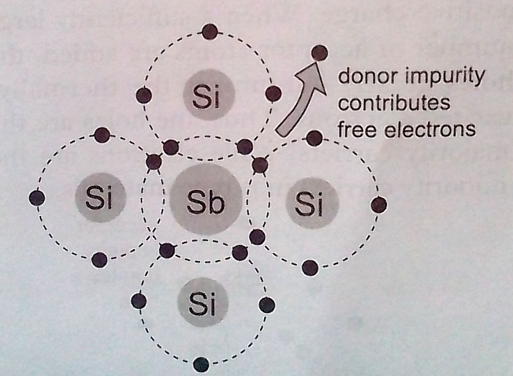

*P-type semi-conductors*

The impurity within the semi-conductor accepts atoms with free electrons (dopants). This forms a ‘hole’ within the semi-conductors.

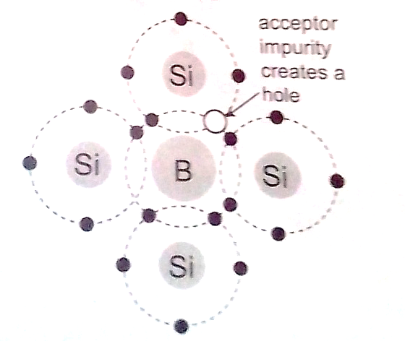

Junction diodes

**Junction refers the region where the two types of semi-conductors meet**. The junctions are made by combining an **n-type** and **p-type** semi-conductor. The **n-region** is the **cathode** and the **p-region** is the **anode.**

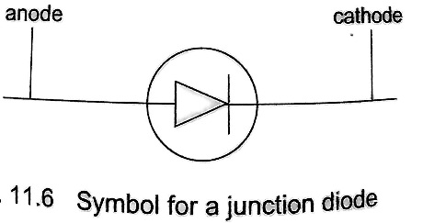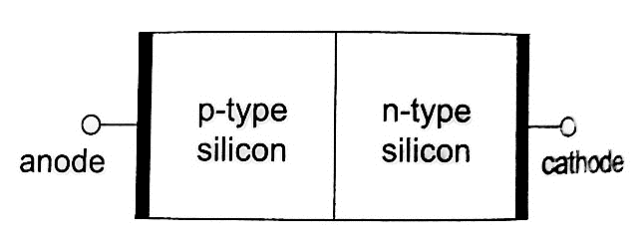

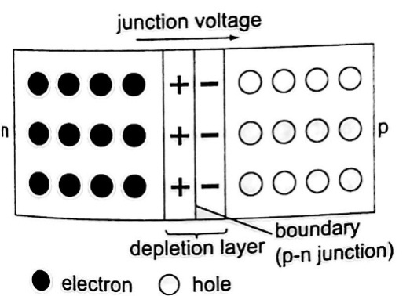

*Forward bias of a p-n junction*

It occurs when the p-type block is connected to the positive terminal and the n-type block is connected to the negative terminal of a battery. The depletion layer of the junction reduces to be very thin to allow the flow of electric current.

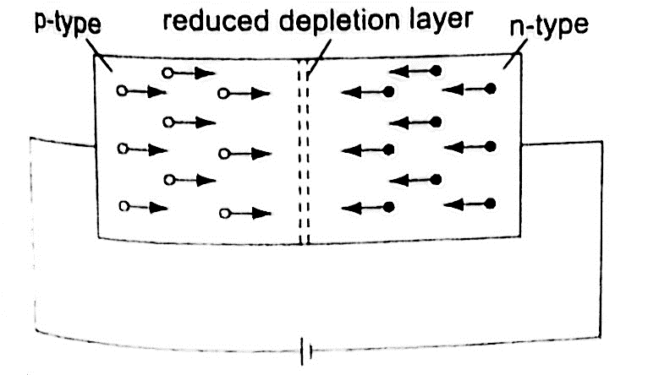

*Reverse bias of a p-n junction*

The negative terminal of the battery is connected to the p-type region while the n-type isconnected to positive terminal.

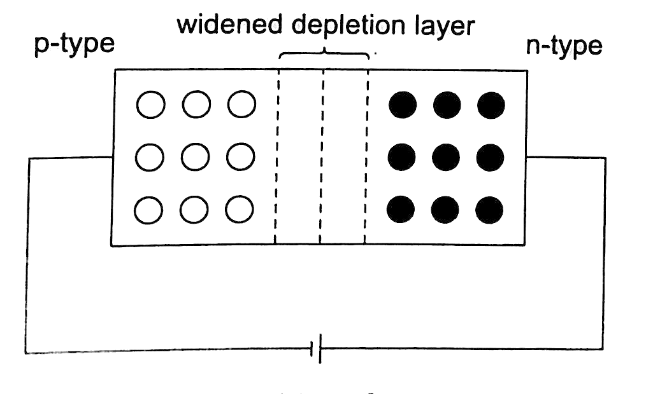

The depletion layer widens and resists the flow of electrons to minimal or zero (no currentflowing through) when the electric field increases beyond critical point the diode junction eventually breaks down and at this voltage it is referred to as the breakdown voltage. Diodes are intended to operate below the breakdown voltage.

Applications of junction diodes

They are **mainly used** for **rectification of a.c. current** for use by many electrical appliances. ***Rectification is the conversion of sinusoidal waveform into unidirectional (non-zero) waveform.***

*Half wave rectification*

In this case the first half cycle of a sinusoidal waveform is positive and the inclusion of a reverse biased diode makes the current not to flow to the negative side of the wave. The current therefore conducts on every half cycle hence a half wave rectification is achieved. The voltage is d.c. and always positive in value though it is not steady and needs to be smoothed by placing a large capacitor in parallel to the load as shown.

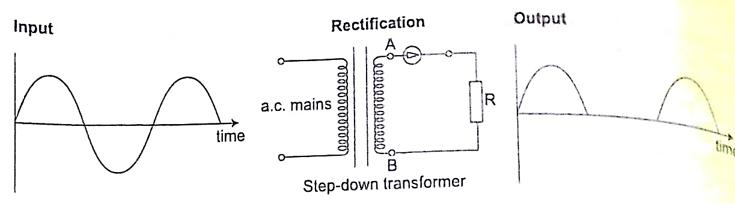

*Centre-tap full wave rectification*

This is achieved by using a transformer whose output has a centre tap that is taken at two points where one is half the other as shown.

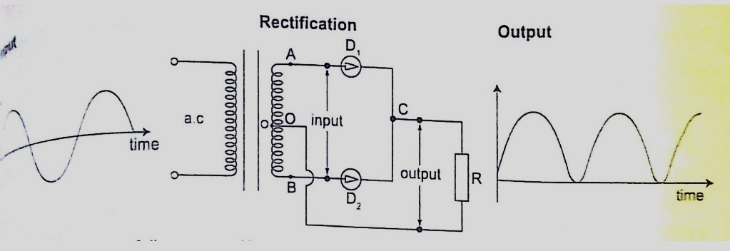

*Bridge full wave rectification*

In this case a bridge rectifier is used to achieve a full wave rectification. The current flows in the same direction in both half cycles.

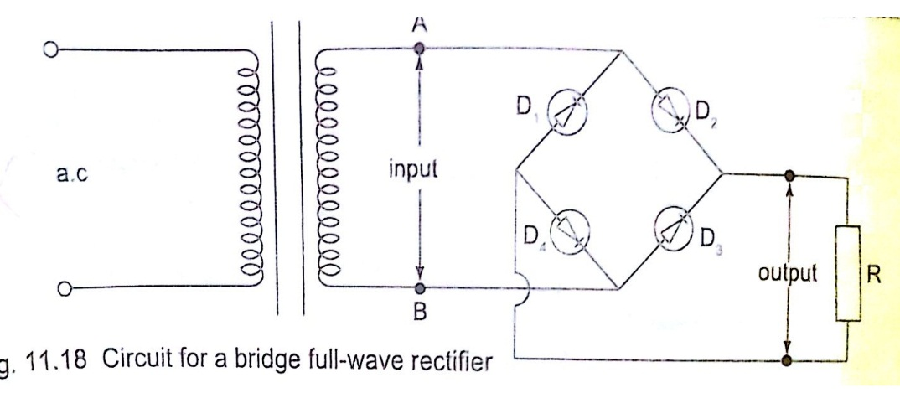

*Radio transmitter and receiver*

Radio waves are produced by circuits that make electrons vibrate and they are known as oscillators which produce varied frequencies. Since radio waves have greater range in air than sound or even light waves they are used as carriers of audio (sound) and visual information (TV) waves. The sound is first changed into electrical vibrations by use of a microphone or other device then added to the radio carrier wave and this changes the amplitude of the carrier and is called amplitude modulation. The modulated wave is given out by the transmitting aerial and received by another aerial in a radio or TV when they cause vibrations between the earth and the aerial. They are then demodulated by a diode and hence heard as a sound or image.

